**Practical No. 2**

**Aim:** Installation and configuration of virtualization using KVM.

**Step 1: Download the Ubuntu ISO**

1. Visit the Ubuntu Downloads page: <https://ubuntu.com/download/desktop>.
2. Select the latest version of Ubuntu (e.g., Ubuntu 22.04 LTS).
3. Download the ISO file (e.g., ubuntu-22.04-desktop-amd64.iso).

**Step 2: Create a New Virtual Machine in VMware Workstation Pro**

1. Open VMware Workstation Pro 17.
2. From the home screen, click on **Create a New Virtual Machine**.
3. Select **Typical (recommended)** and click **Next**.
4. Choose **Installer disc image file (iso)** and browse to the downloaded Ubuntu ISO.
5. Choose the VM name (e.g., "Ubuntu-KVM") and select a location for the virtual machine.
6. Set the disk size (e.g., 20 GB or higher) and choose **Store virtual disk as a single file**.
7. Finish the wizard by clicking **Finish**.

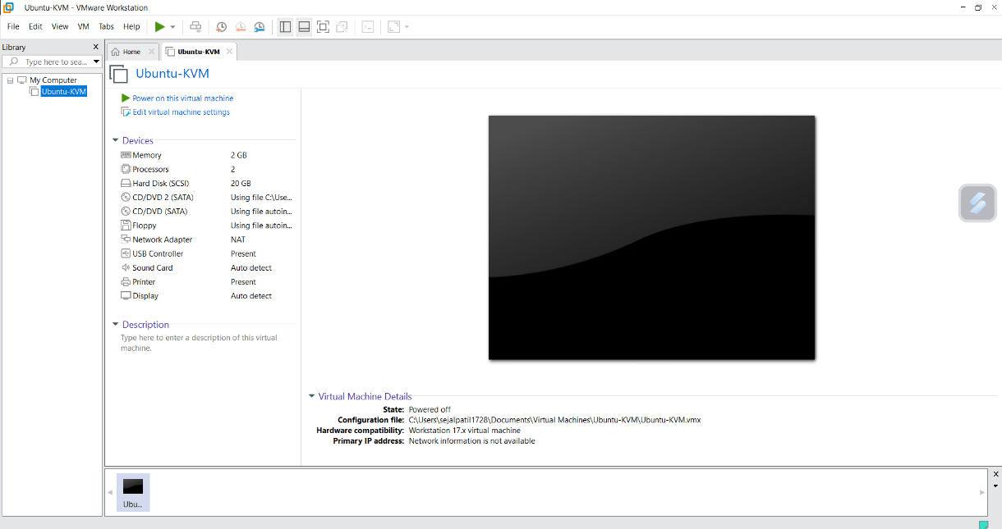

**Step 3: Power On the Virtual Machine and Install Ubuntu**

1. Once the virtual machine is created, select it in VMware and click **Power on**.
2. The Ubuntu installation will begin.

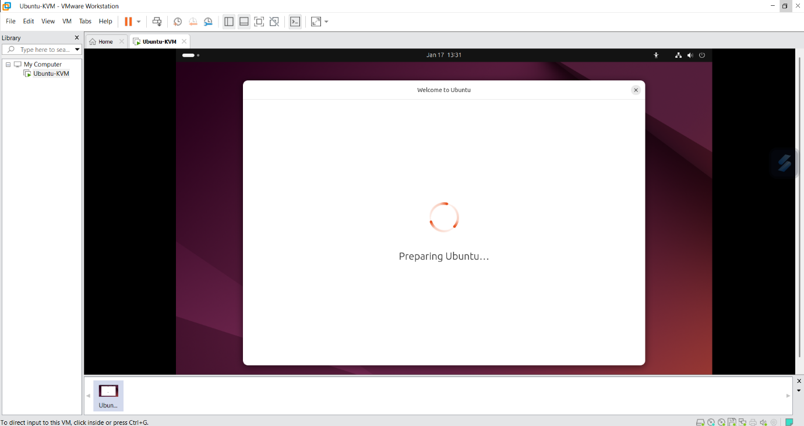

1. Follow the on-screen instructions to complete the Ubuntu installation (Language, Time zone, User setup, etc.).

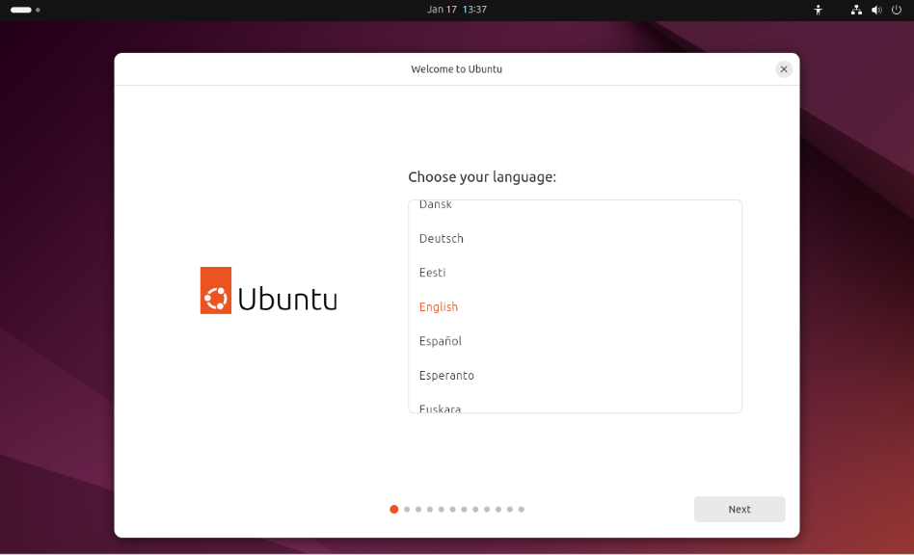

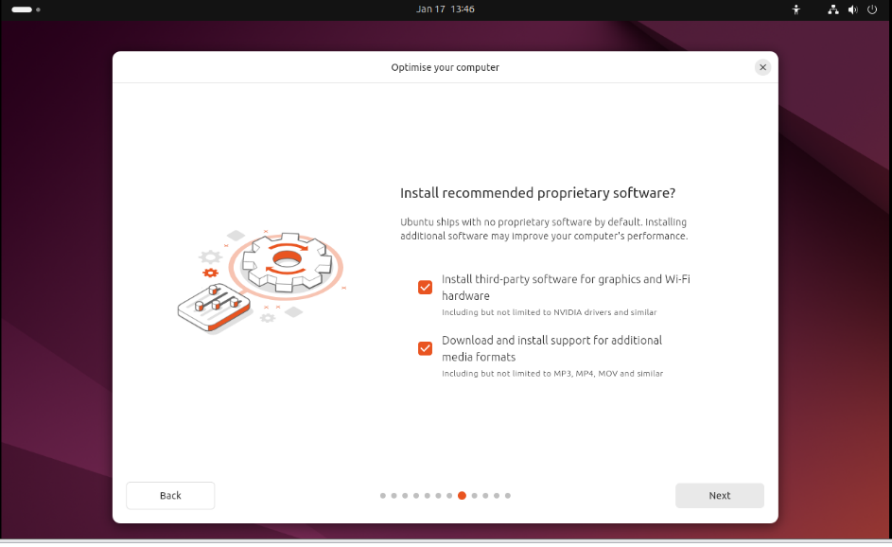

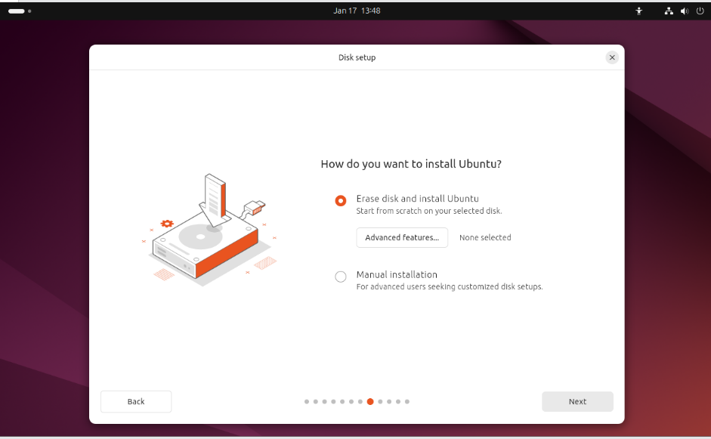

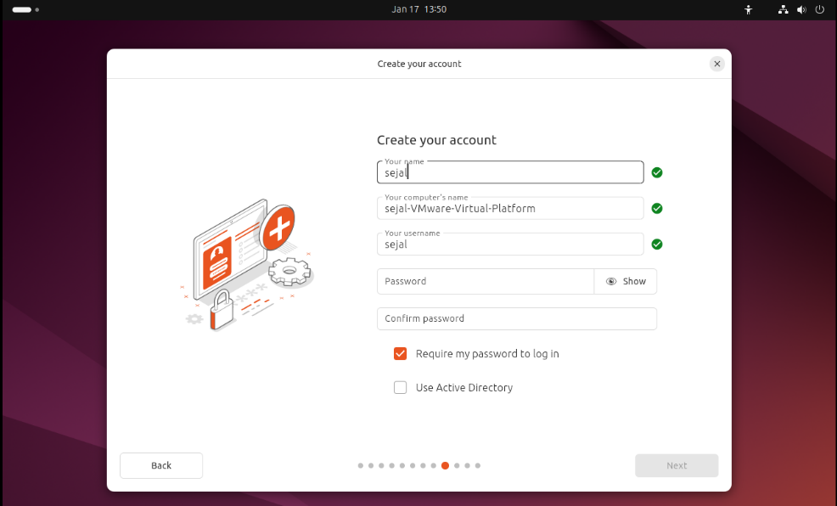

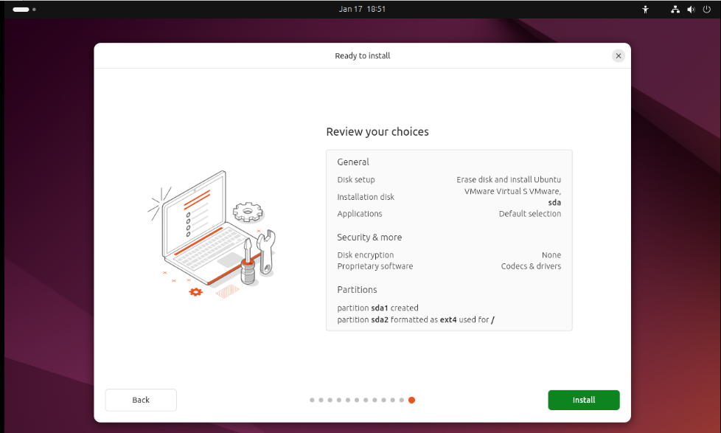

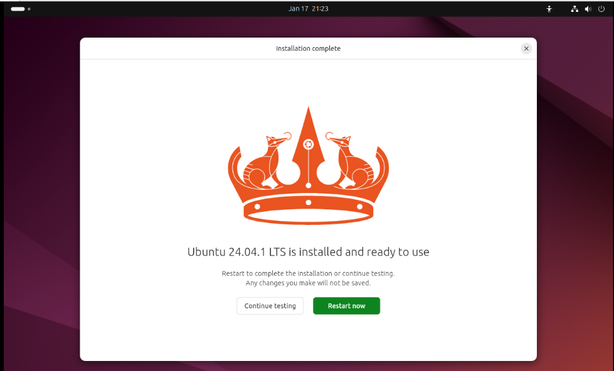

1. When the installation is complete, reboot the system.

**Step 4: KVM Related Packages in Ubuntu**

1. Once Ubuntu is installed, log in to the system.

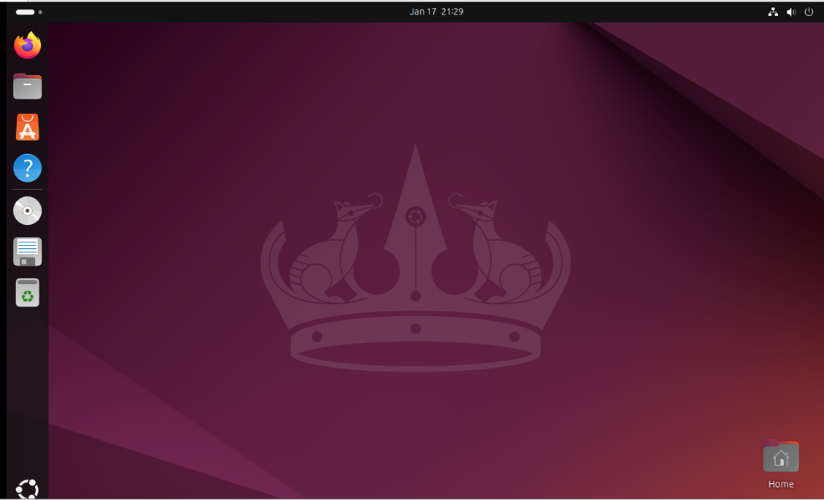

1. Open a Terminal in Ubuntu and execute the following commands to check if your system supports virtualization:

sudo grep -c "svm\|vmx" /proc/cpuinfo

* + **svm**: AMD processors.
  + **vmx**: Intel processors.

If the output is greater than 0, your CPU supports virtualization.

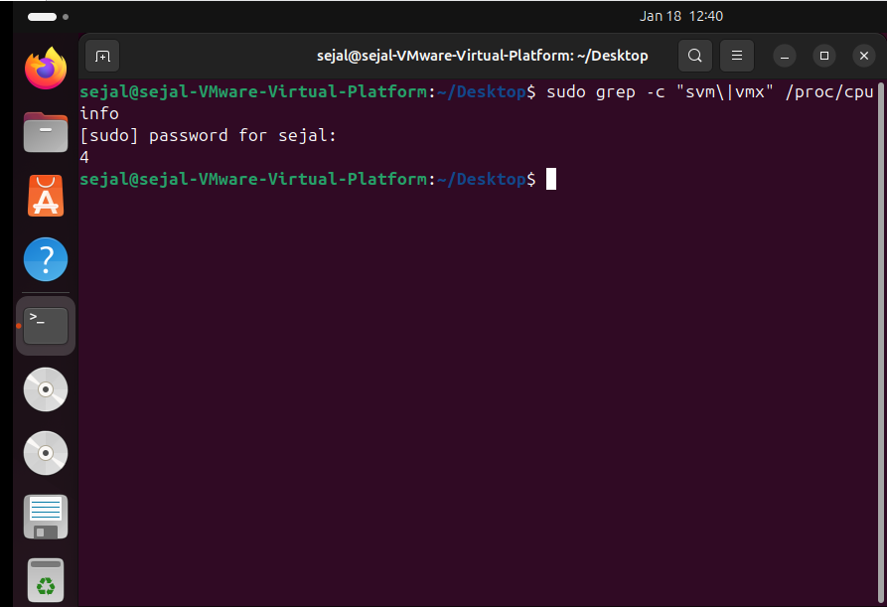

1. Install KVM and related packages by running the following commands:
2. sudo apt update

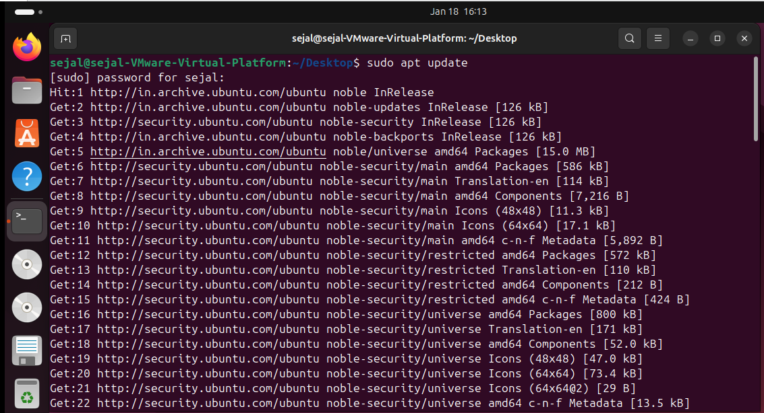

1. sudo apt upgrade

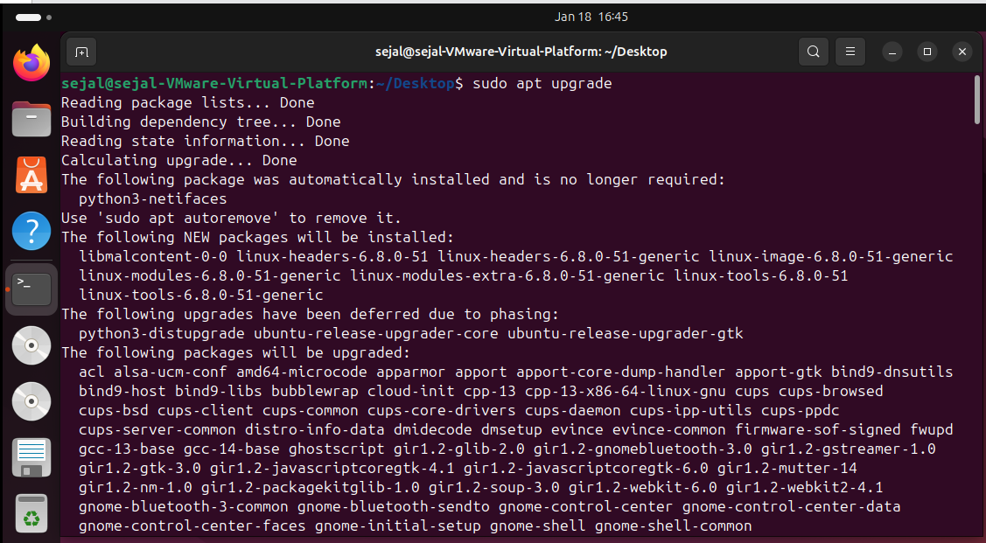

**Step 4: Verify if KVM virtualization is enabled**

* 1. sudo apt install cpu-checker

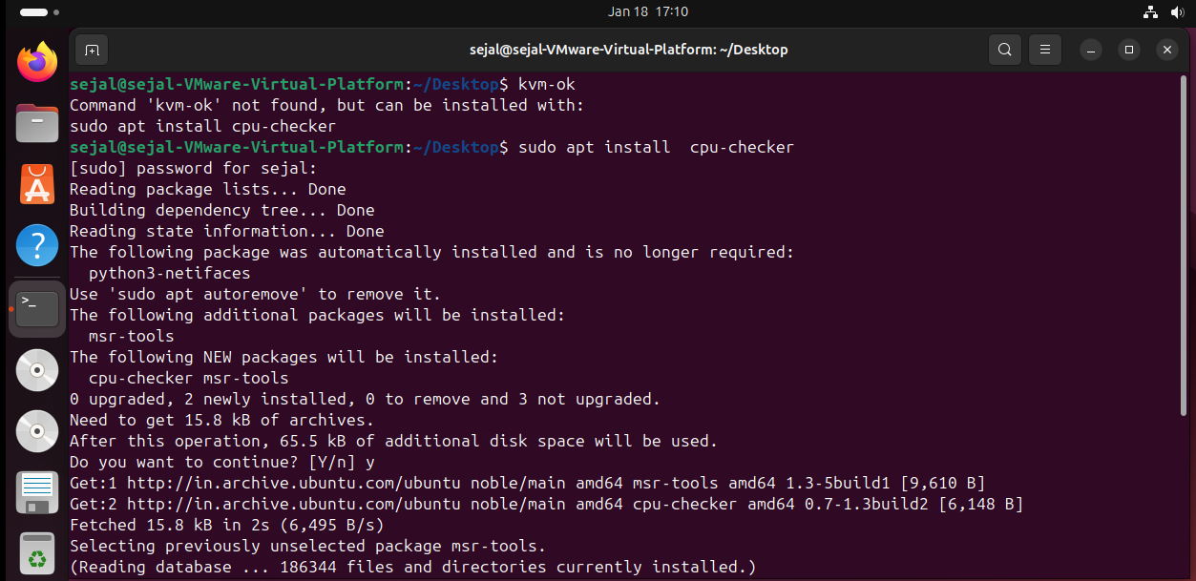

* 1. kvm-ok

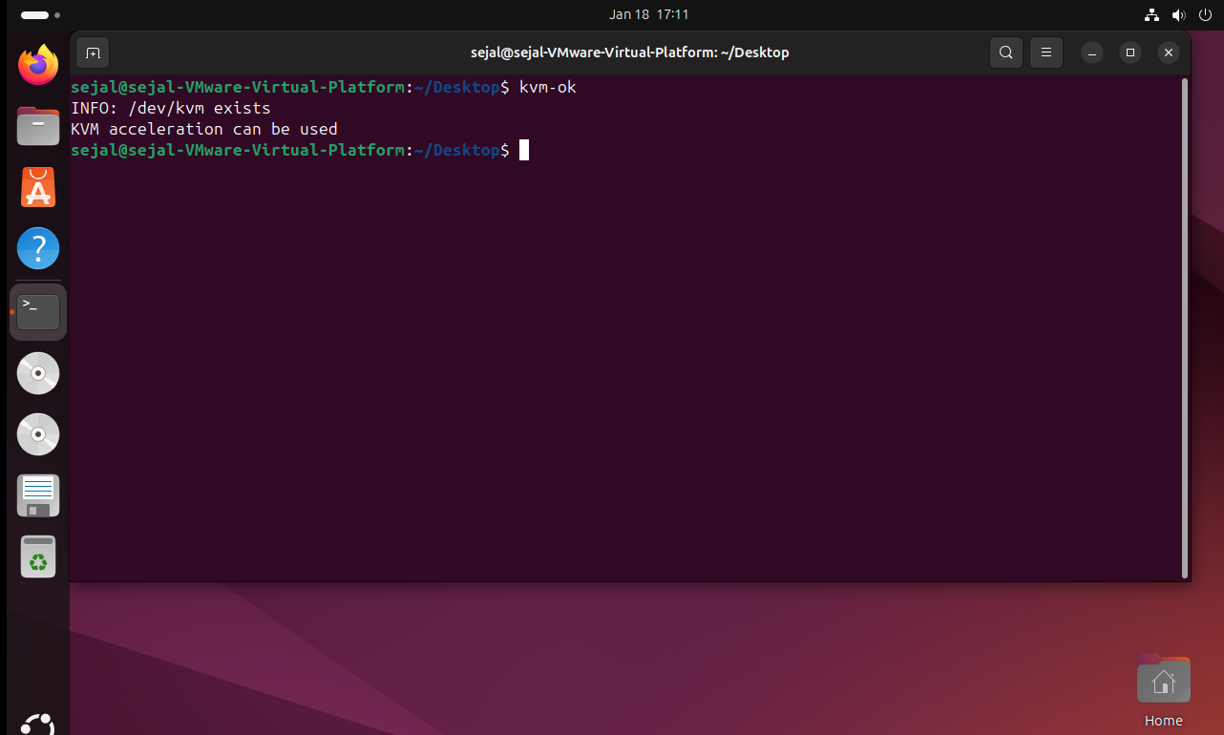

**Step 5: Install KVM**

* 1. sudo apt install qemu-kvm virt-manager libvirt-daemon-system virtinst libvirt-clients bridge-utils

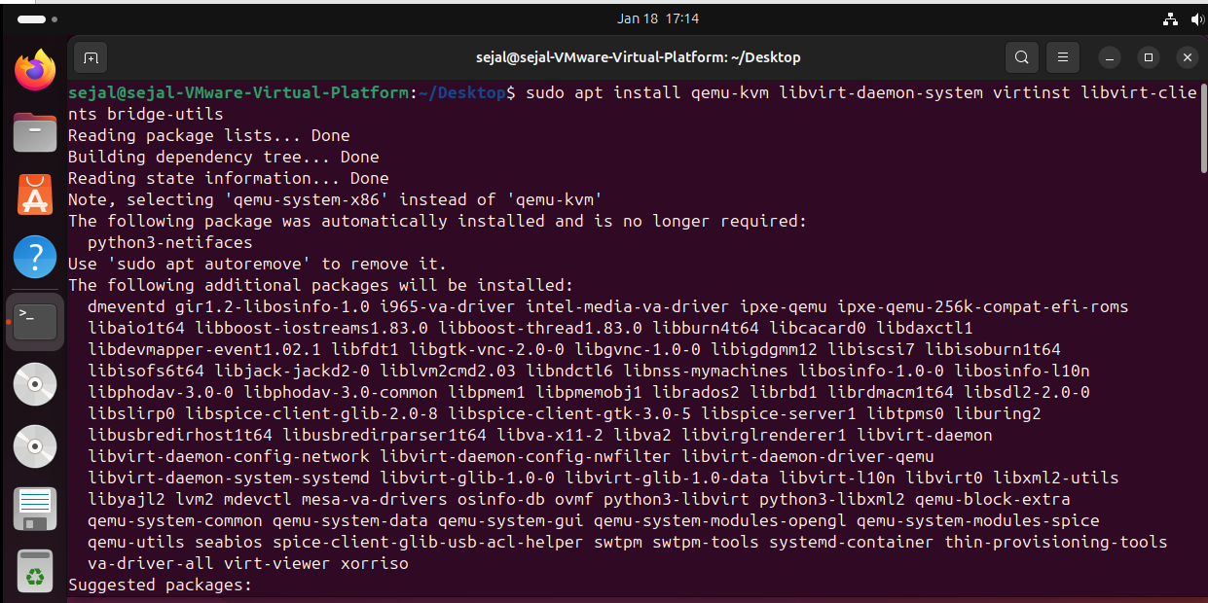

**Step 6 : Enable the virtualization daemon**

1. Sudo systemctl enable –now libvirtd
2. subo systemctl start libvirtd
3. subo systemctl status libvirtd

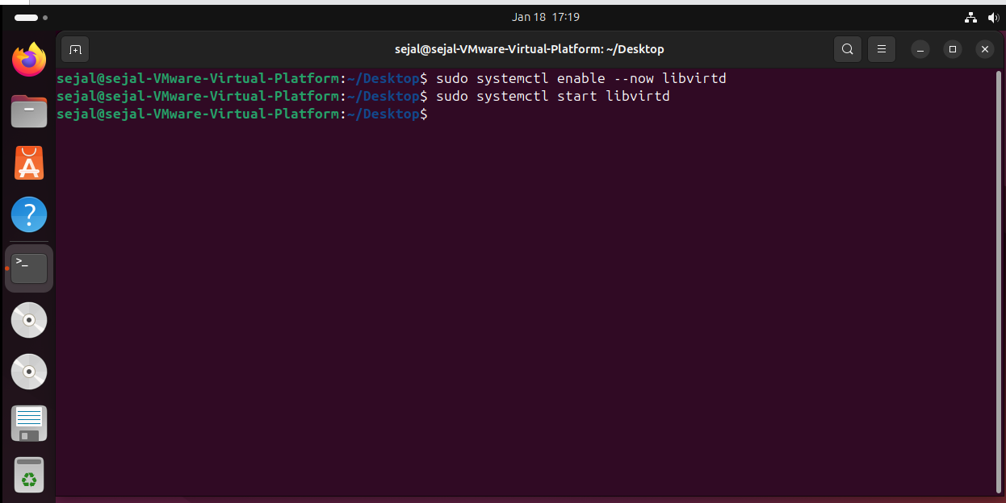

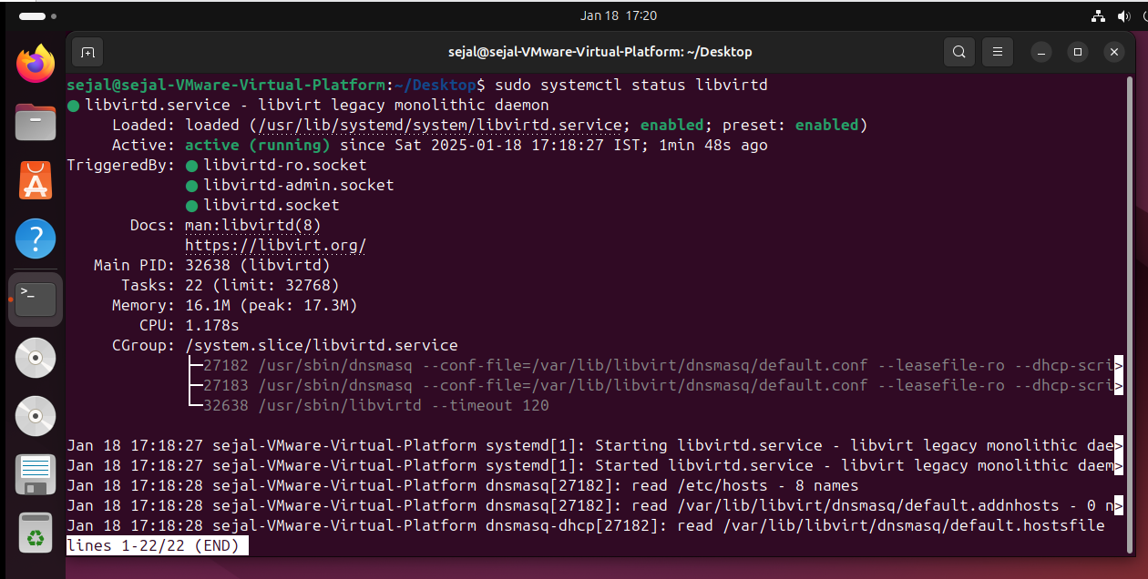

**Step 7: Add your user to the KVM and libvirt group and kvm group**

1. sudo adduser sejal libvirt

2. sudo adduser sejal kvm

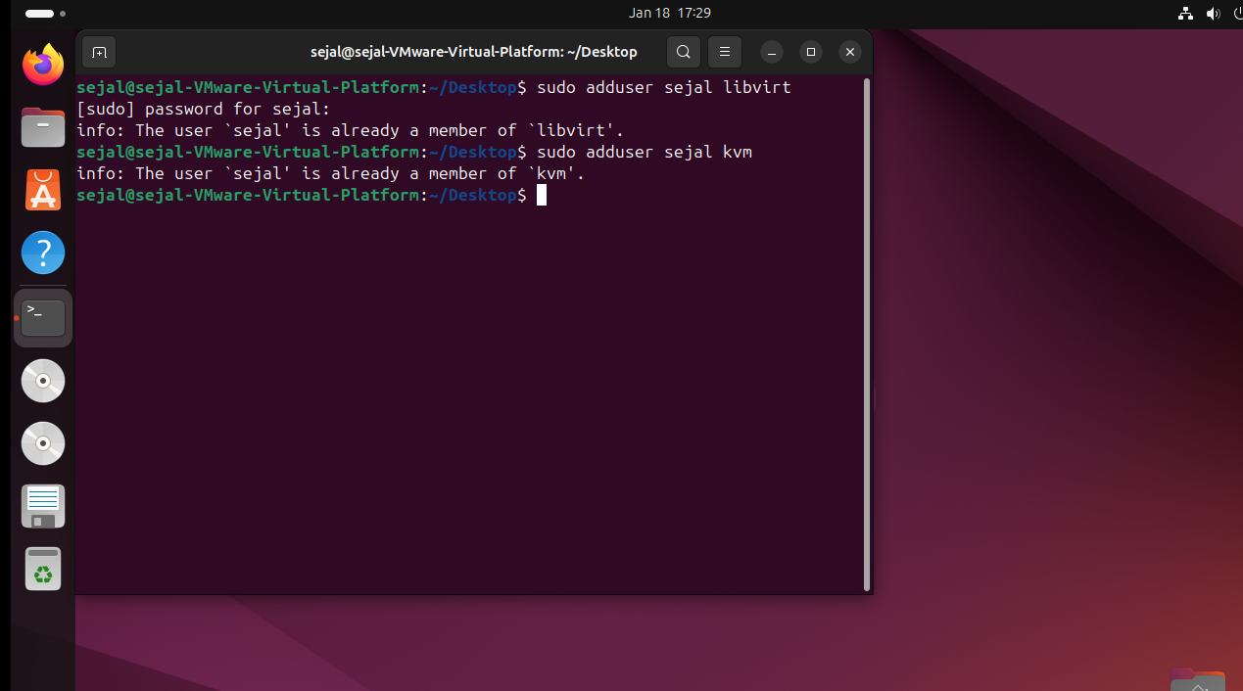

**Step 8 : Install the virt-manager**

1. sudo apt install virt-manager

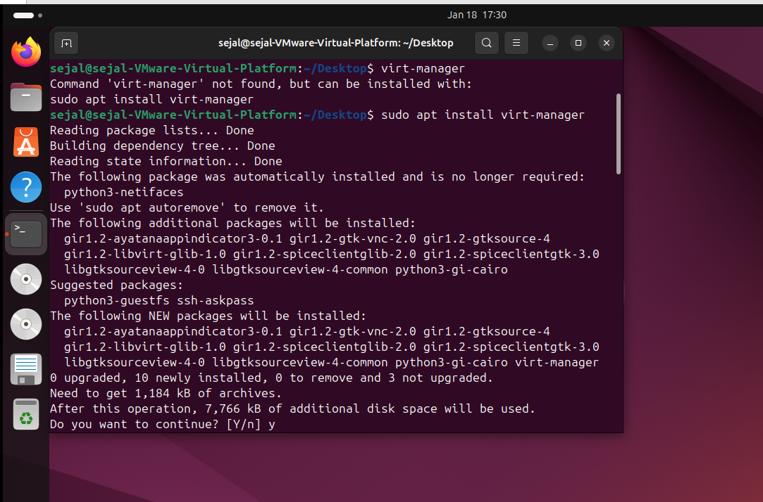

**Step 9 : Search the virtual machine or run “virt-manager” command.**

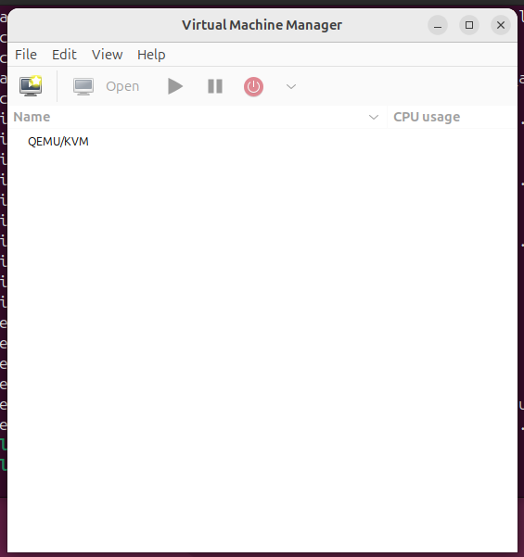

**Conclusion:**

You have successfully installed and configured KVM inside a virtual machine on VMware Workstation Pro 17 running Ubuntu. Now, you can create multiple virtual machines using KVM within this virtual environment.

**Practical No. 3**

**Aim:** Create and manage virtual machines using KVM.

**Steps to Install Windows OS on KVM**

**1. Verify KVM Installation**

1. Ensure KVM is installed and active:

**sudo systemctl status libvirtd**

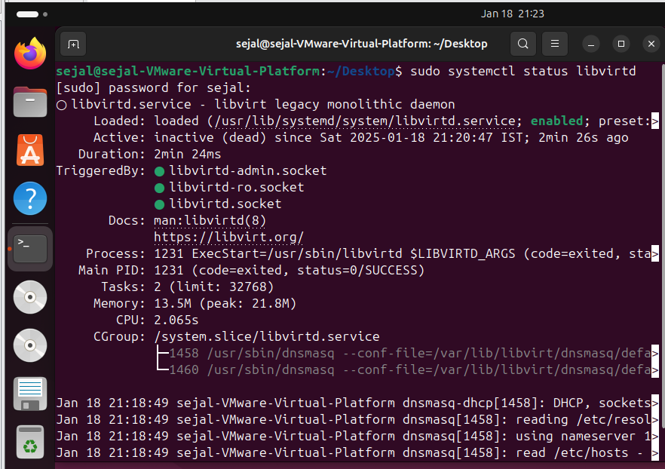

If not active, start the service:

**sudo systemctl start libvirtd**

1. Confirm KVM installation:

**kvm-ok**

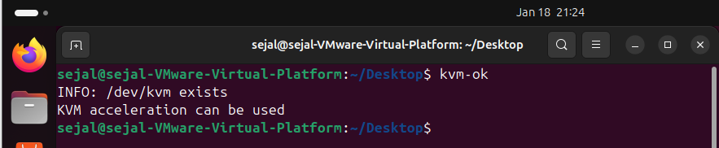

If it returns **"KVM acceleration can be used"**, KVM is properly installed.

**2. Download Windows ISO**

* Download the required Windows ISO file from the official Microsoft website.

(<https://www.microsoft.com/en-in/software-download/windows10b>)

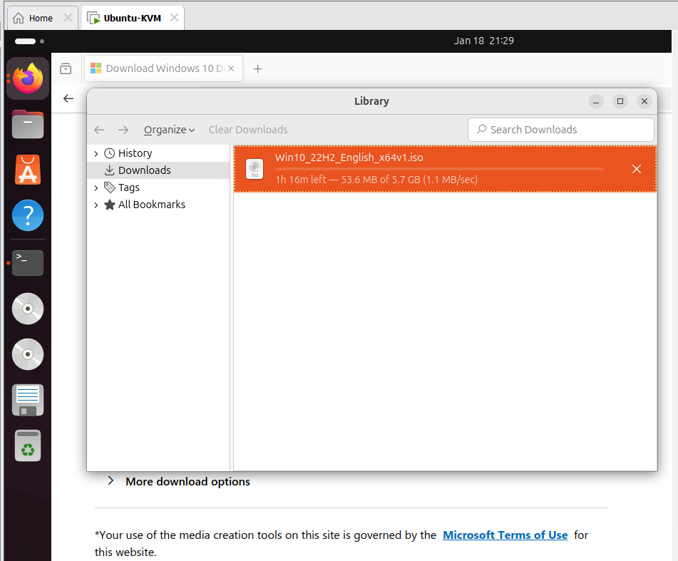

* Save it to a directory accessible from your Ubuntu system, e.g., /home/user/Downloads/windows.iso.

**3. Start Virt-Manager**

1. Open **Virt-Manager** (Virtual Machine Manager) on your Ubuntu system:
   * Run it from the terminal:

virt-manager

* + Or search for it in your application menu.

1. Ensure that the libvirtd service is running to allow Virt-Manager to manage virtual machines.

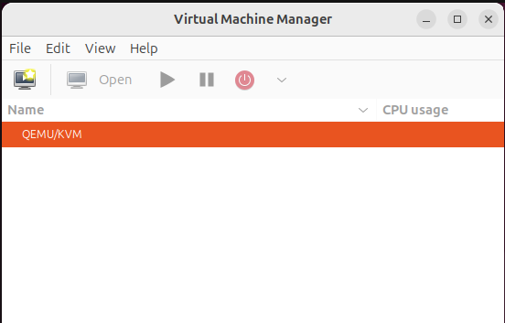

**4. Create a New Virtual Machine**

1. In Virt-Manager:
   * Click **File > New Virtual Machine** or the **+ Create a New Virtual Machine** button.
2. Choose the **Install method**:
   * Select **Local install media (ISO image or CDROM)** and click **Forward**.
3. Provide the ISO:
   * Browse to the location of the downloaded Windows ISO (e.g., /home/user/Downloads/windows.iso).

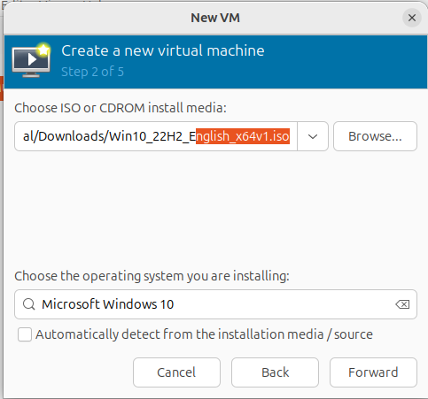

1. Configure the Windows VM:
   * Operating System: Select **Microsoft Windows** and choose the version (e.g., Windows 10/11).
   * Allocate **RAM**: At least 4GB (4096 MB).
   * Allocate **CPU Cores**: At least 2 cores.

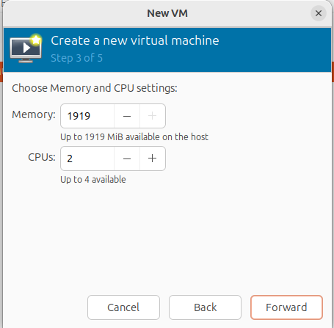

1. Create a Virtual Disk:
   * Set the disk size: At least **50GB**.
   * Ensure the storage is **qcow2** for dynamic allocation.
2. Name the Virtual Machine:
   * Give a name, e.g., "Windows VM", and confirm the settings.

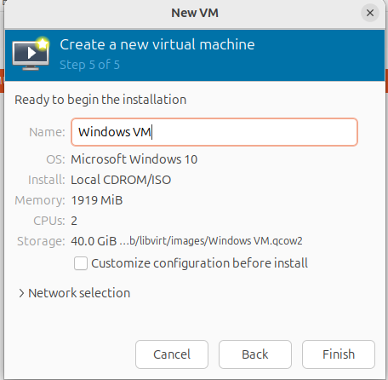

**5. Start the Installation**

1. Click **Finish** to start the virtual machine.
2. The VM will boot from the Windows ISO.
3. Follow the Windows installation process:
   * Choose language, region, and keyboard layout.
   * Select **Custom installation** and create a partition on the virtual disk for Windows.
   * Complete the installation process.

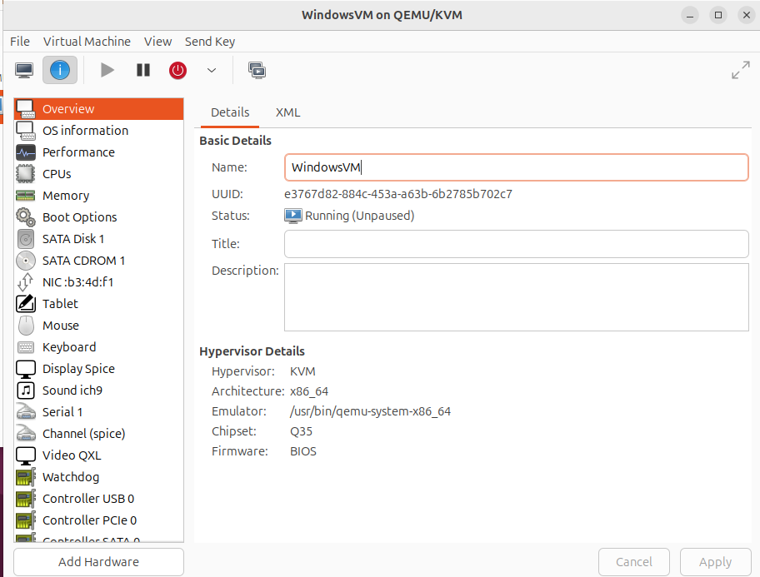

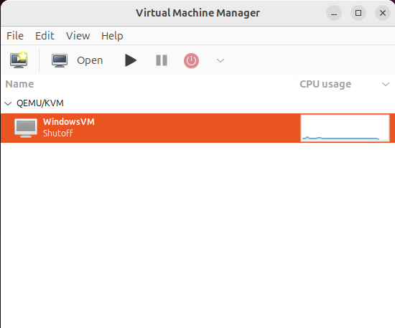

**7. Access and Use Windows**

* Once the installation is complete, you can log in to your Windows VM.
* Install required software or services in the Windows VM.

This setup successfully demonstrates the deployment of **Infrastructure as a Service (IaaS)** by enabling multiple operating systems to run on a single host using KVM.

**Practical No. 4**

**Aim:** To study and implement the concept of Storage as a Service (SaaS).

**Steps to Implement Storage as a Service Using Google Drive**

1. **Open Google Drive:**
   * Go to [Google Drive](https://drive.google.com).

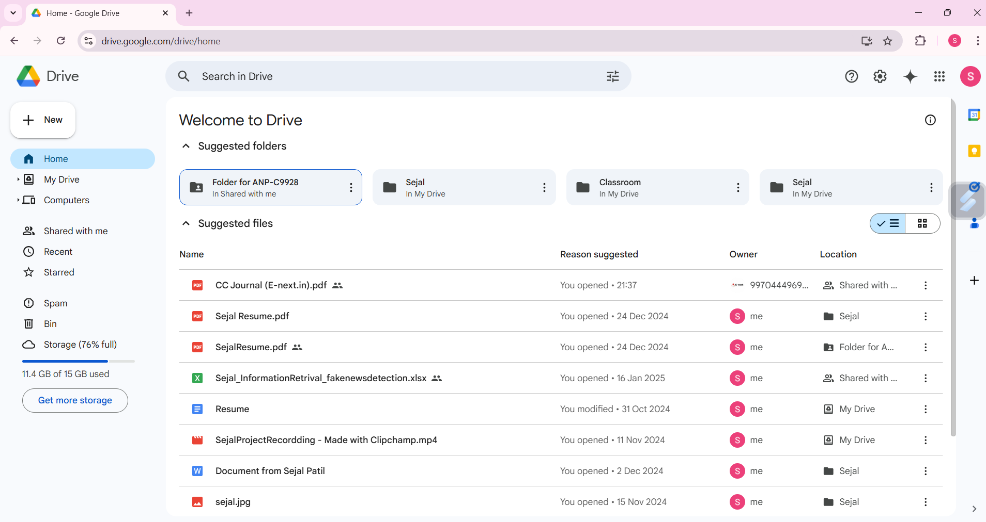

1. **Create a Folder:**
   * Click on the “+ New” button (on the left-hand side).
   * Select “Folder” from the dropdown menu.
   * Provide a name for the folder (e.g., "Personal") and click Create.

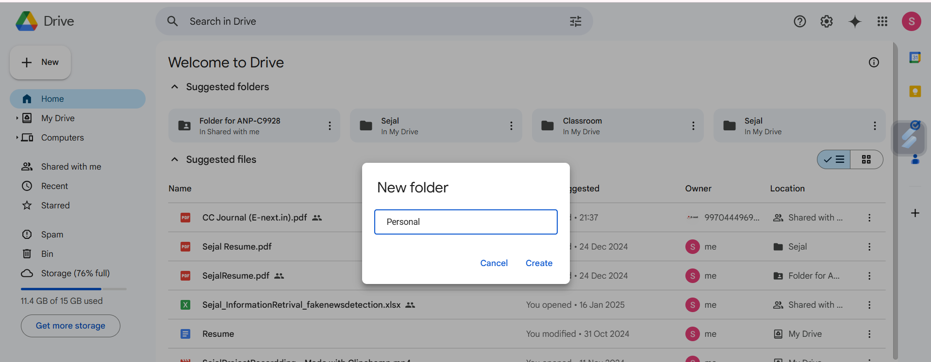

1. **Store a File in the Folder:**
   * Open the created folder by clicking on its name.
   * Click on the “+ New” button again, then choose “File upload”.

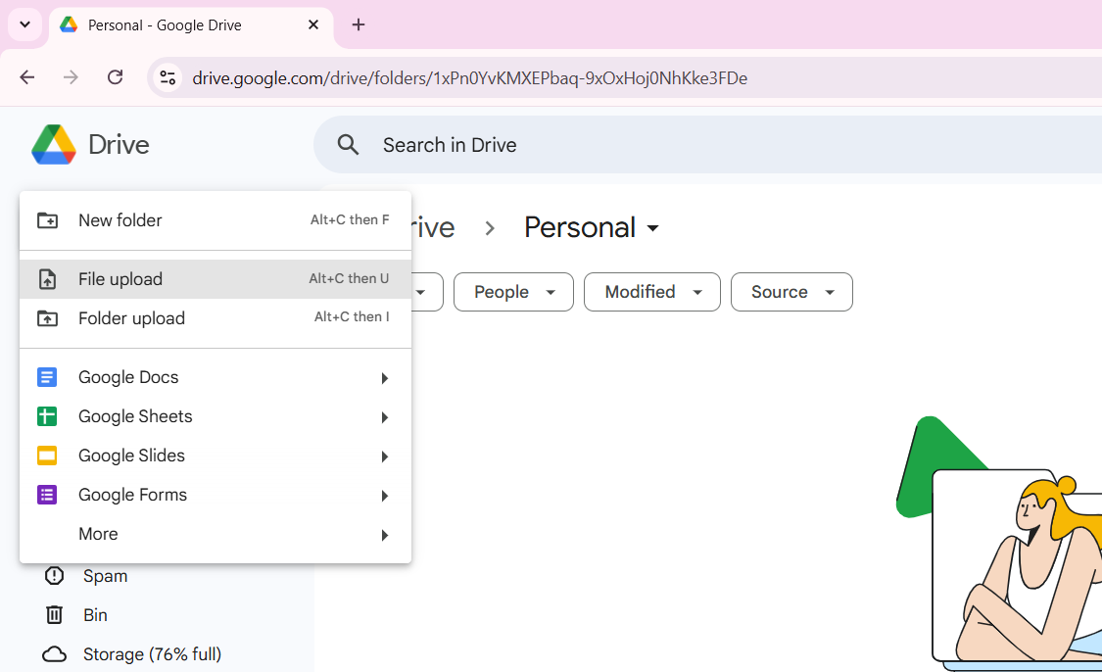

* + Browse and select a file from your device to upload.

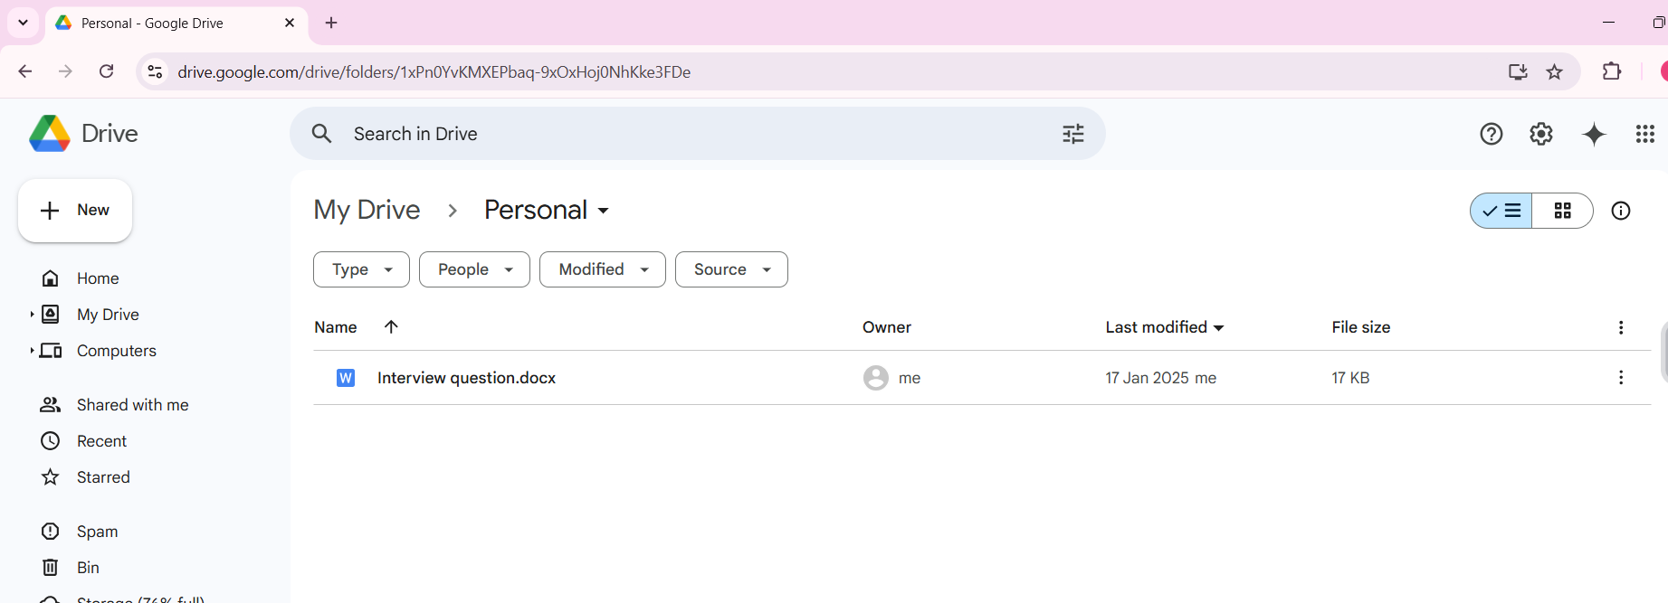

**7. Result**

Files and folders were successfully created and stored in Google Drive. The steps demonstrate the concept of Storage as a Service.

**8. Conclusion**

Google Drive provides an efficient solution for data storage and management. It fits well under the SaaS model, offering options to create and manage documents, spreadsheets, and presentations. Its automatic saving feature and sharing capabilities make it a robust tool for cloud storage.

**Practical No. 5**

**Aim: Study and implementation of identity management**

**Step1: Click on link below.** [**https://aws.amazon.com/console/**](https://aws.amazon.com/console/)

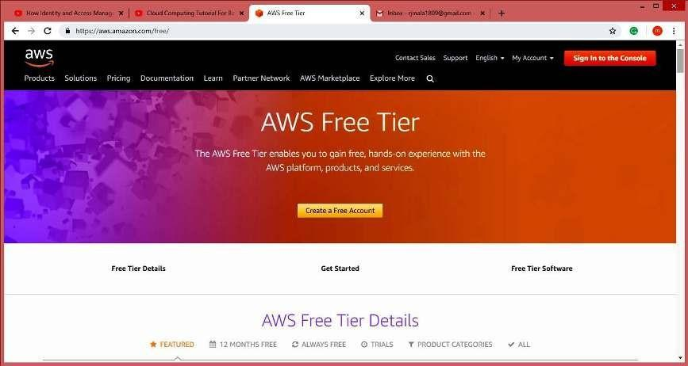

**Step2: Go to “My Account” > “AWS Management Console”**

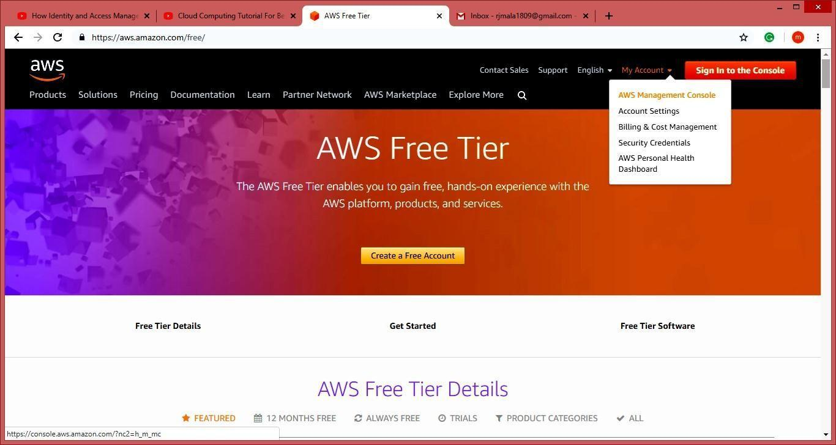

**Step3: Create** **AWS** **account (fill** **the** **required** **details)**

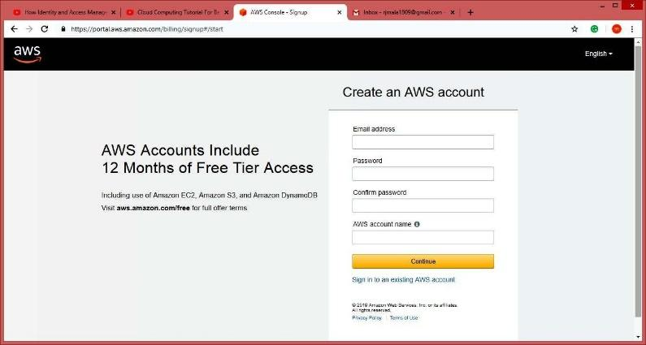

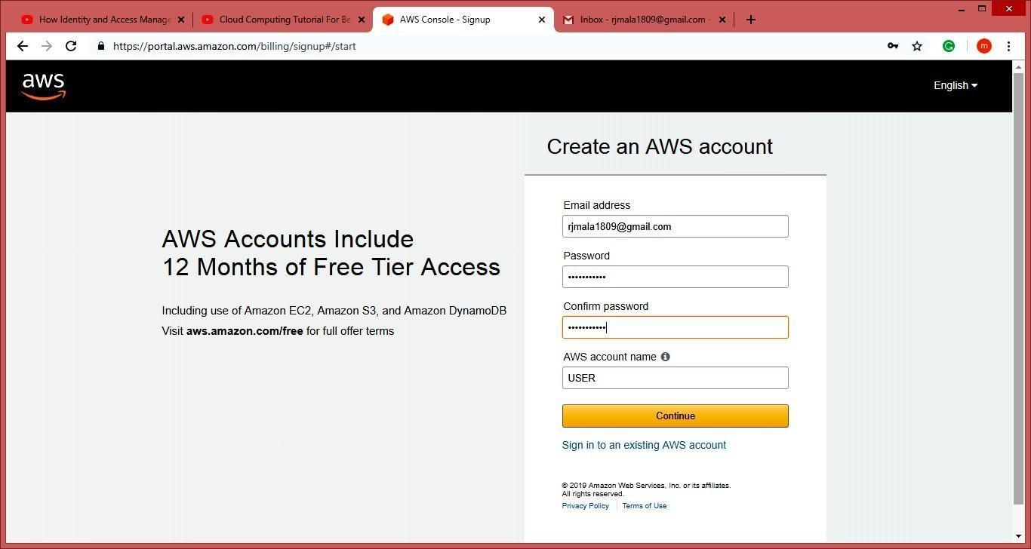

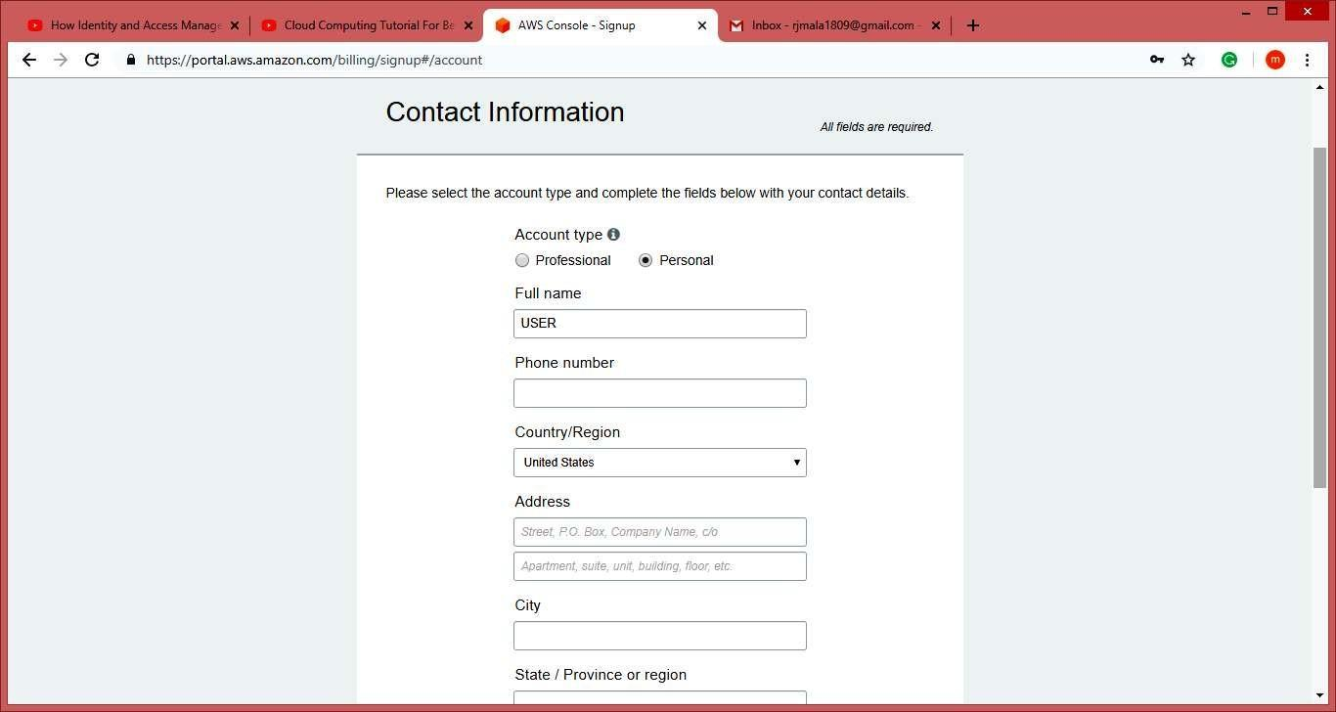

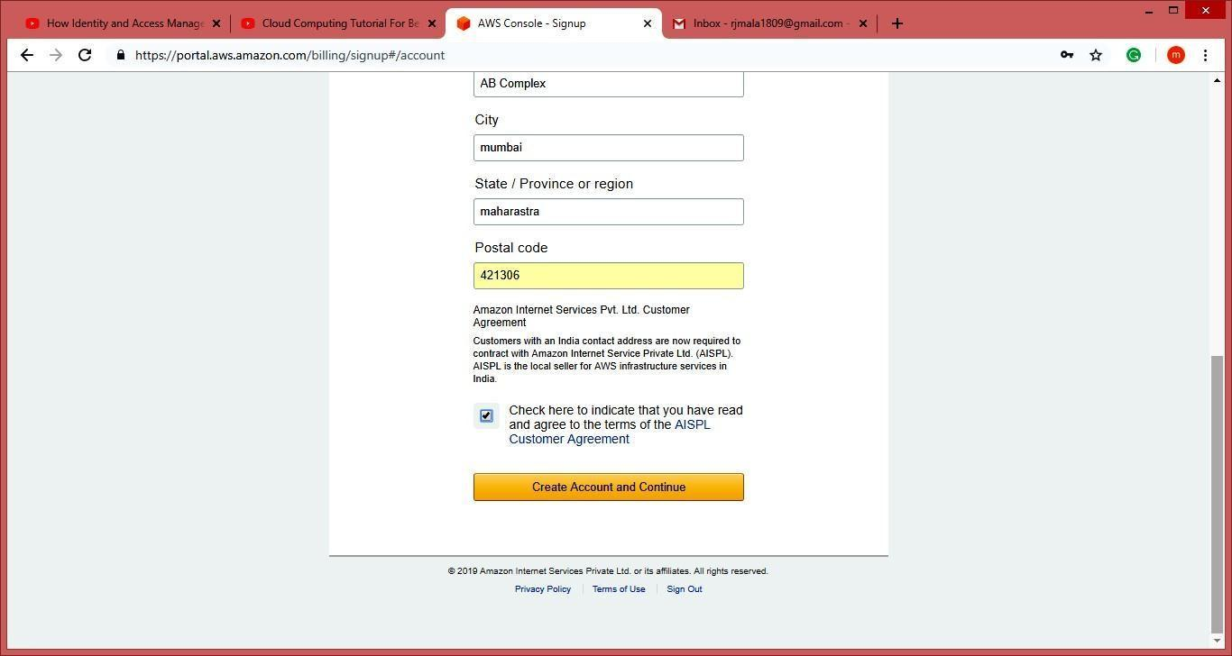

**NOTE: Do** **not** **provide** **any** **kind** **of** **credit/debit** **card** **details** **or** **bank** **details.)** **Click** **on** **next**

**Step 4: Click** **on** **My** **Account,** **Select** **AWS** **Management** **Console.**

**Enter** **your** **aws** **account** **userid** **and** **password** **click** **on** **sign** **in** **button**

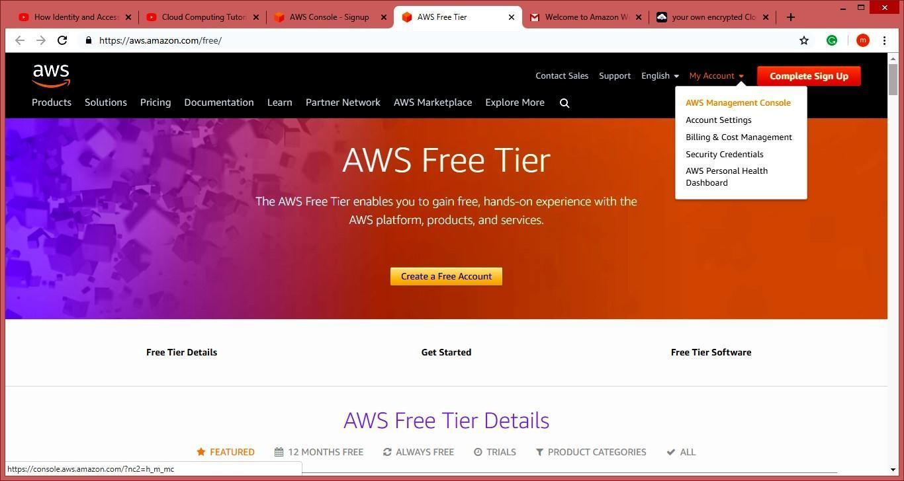

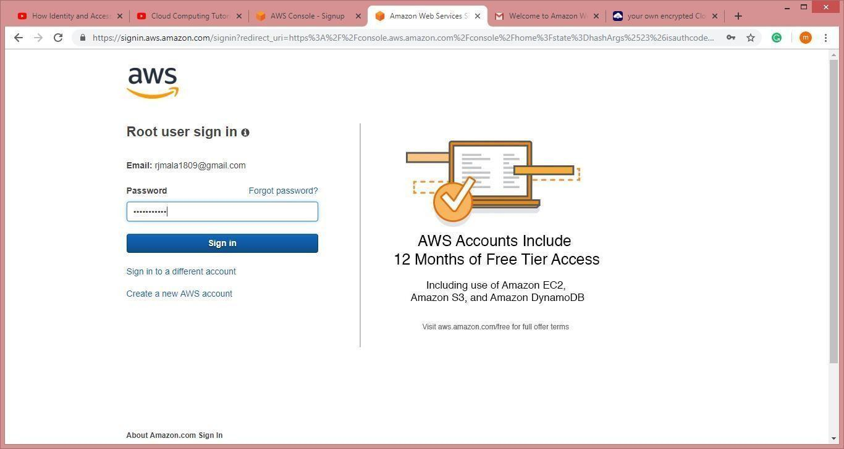

**Now** **it** **will** **redirect** **you** **to the home** **page** **without** **asking for any** **other** **details.** **Now we** **have** **to** **add** **users** **and** **groups** **and** **assign** **them** **privileges.**

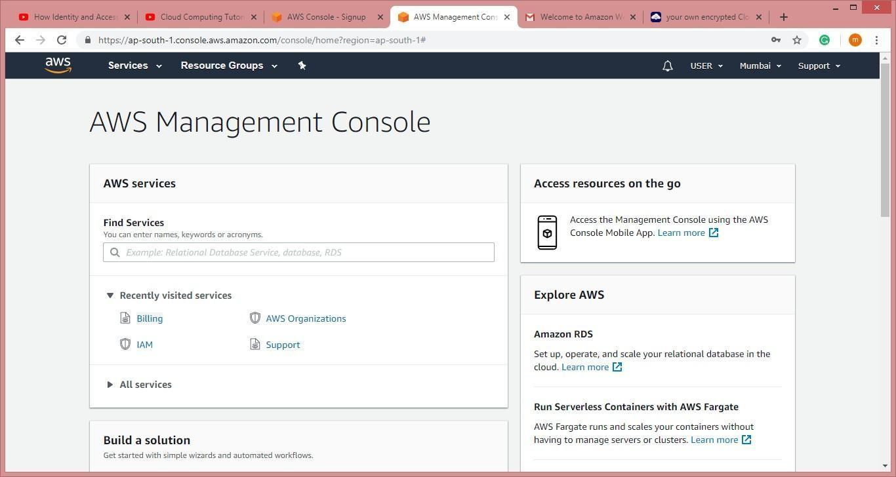

**Step 5: Go to “My Security Credentials”. Click on “Users”.**

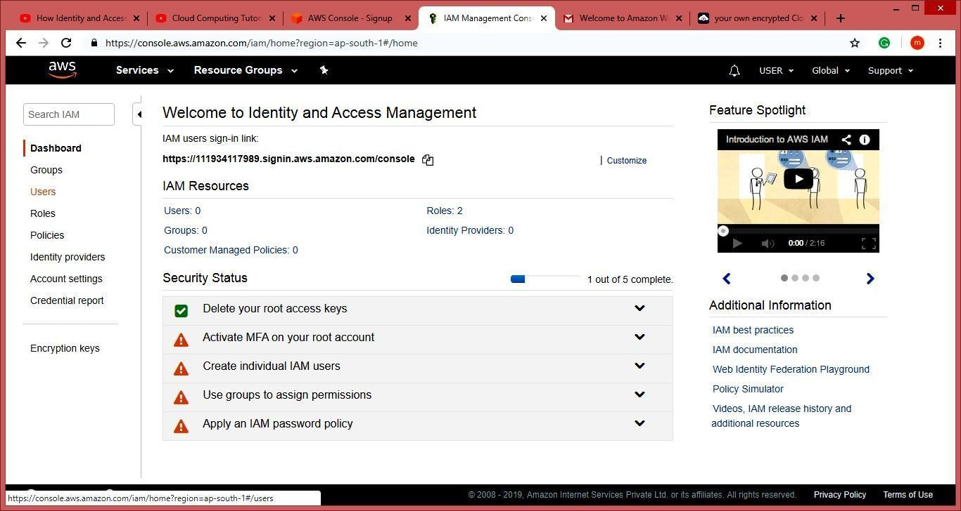

**Step6: Click on “Add user”.**

**Enter the name for the user. Check the check box in front of “Programmatic access” and “AWS Management Console access”.**

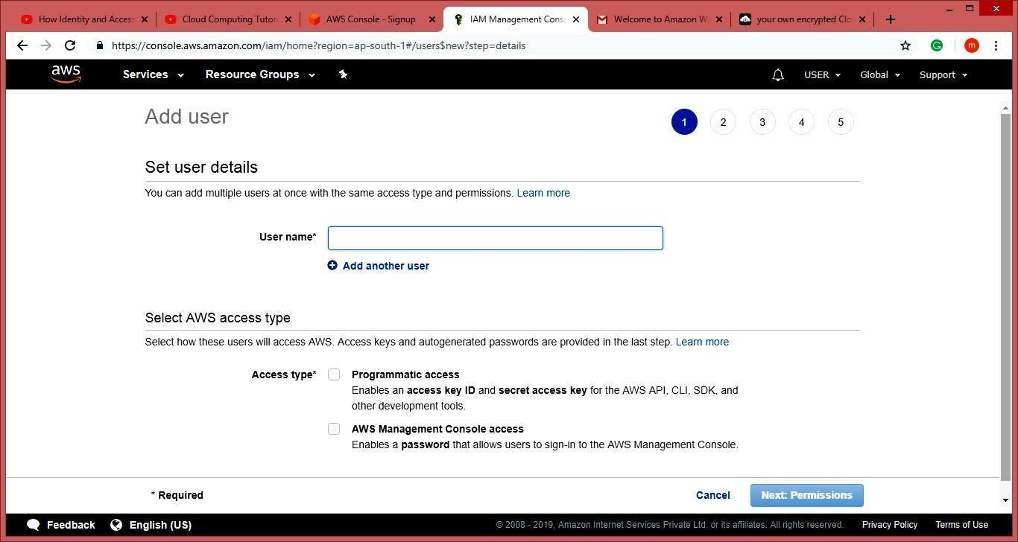

**Step7: Scroll down and select “Custom password” and enter the password for the new user and**

**Click on “Next: Permissions”.**

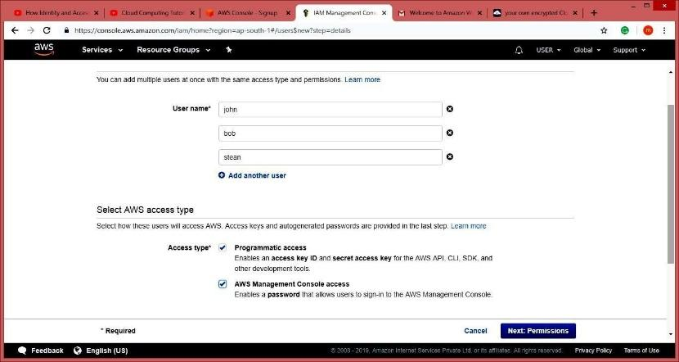

**Step8: Next** **it** **allow** **you** **to** **create** **group** **or** **you** **can** **just** **pass** **it.** **We** **are** **going** **to** **create** **group** **click** **on**

**“Create group”.**

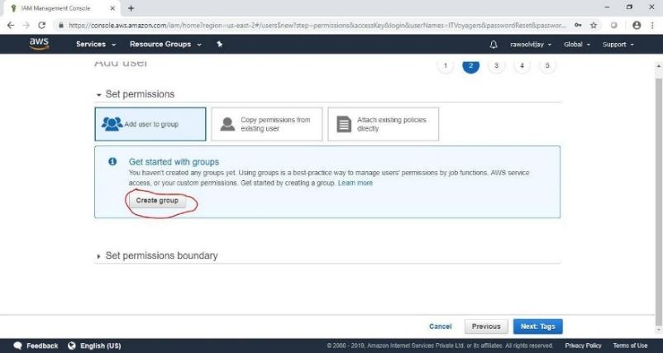

**Following window will appear.**

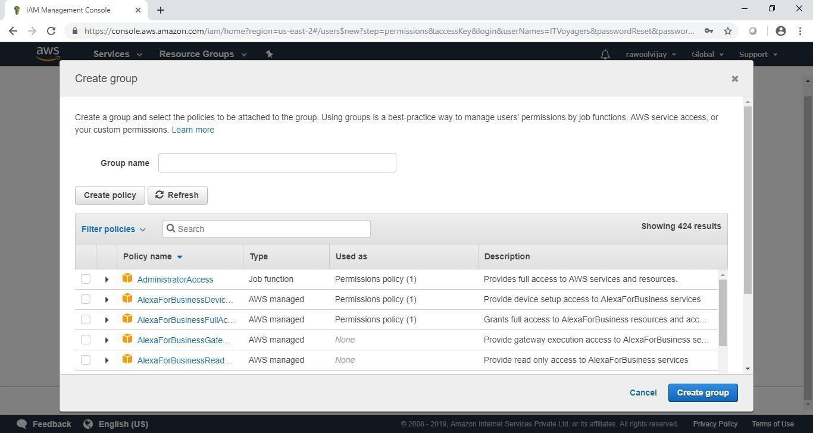

**Step9: Give** **name** **to group, assign the their permissions and click on “Create group”.**

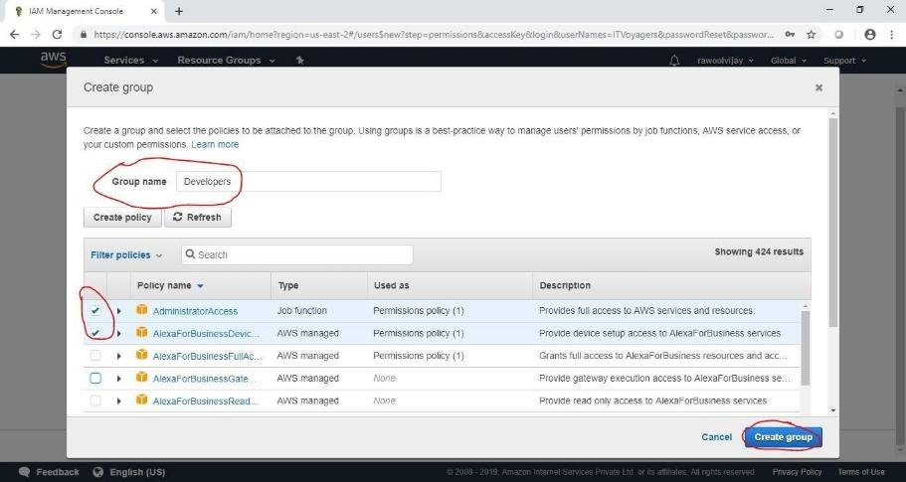

**Step10: Your group is created now click on “Next: Tags”.**

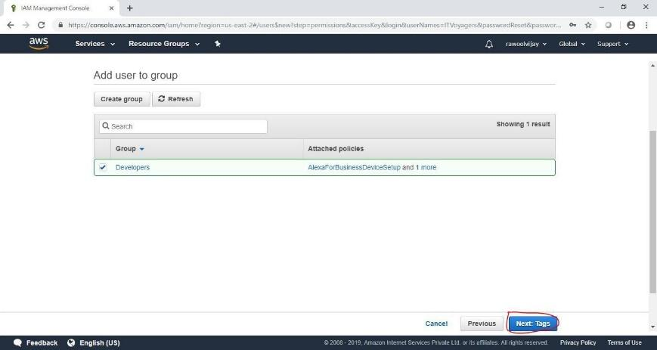

**Step11: Click on “Next: Review”.**

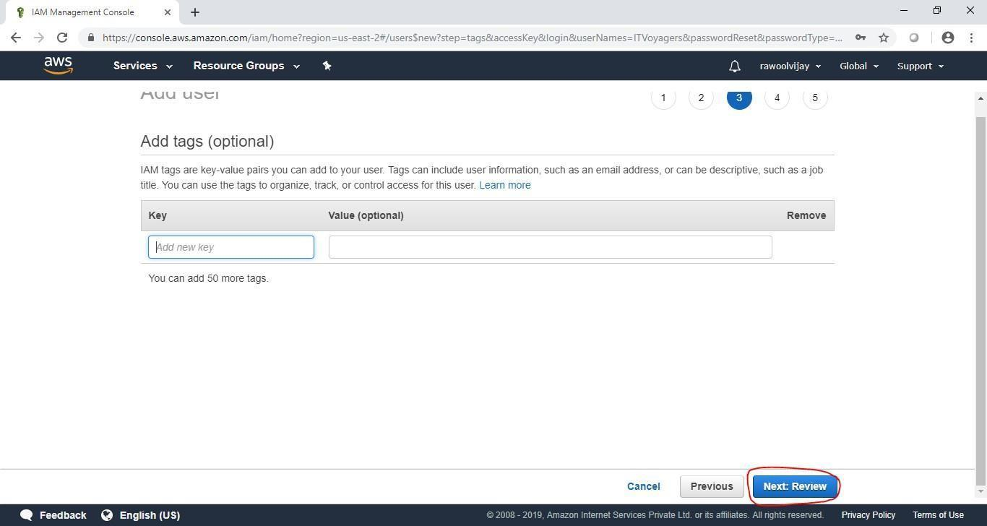

**Step12: Check the Review for the user and click on “Create user”.**

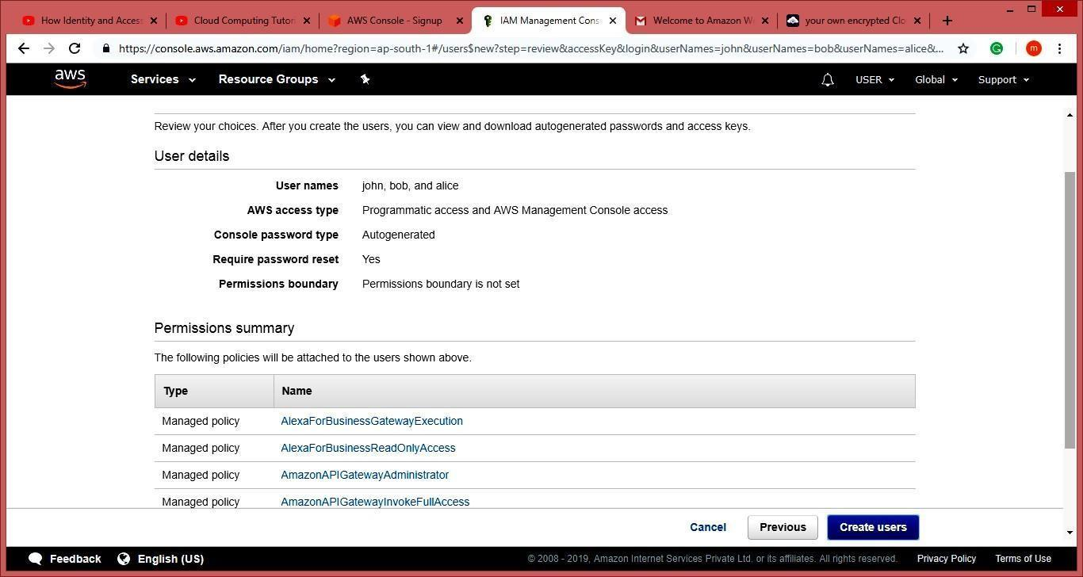

**Step13: Click on “Close”.**

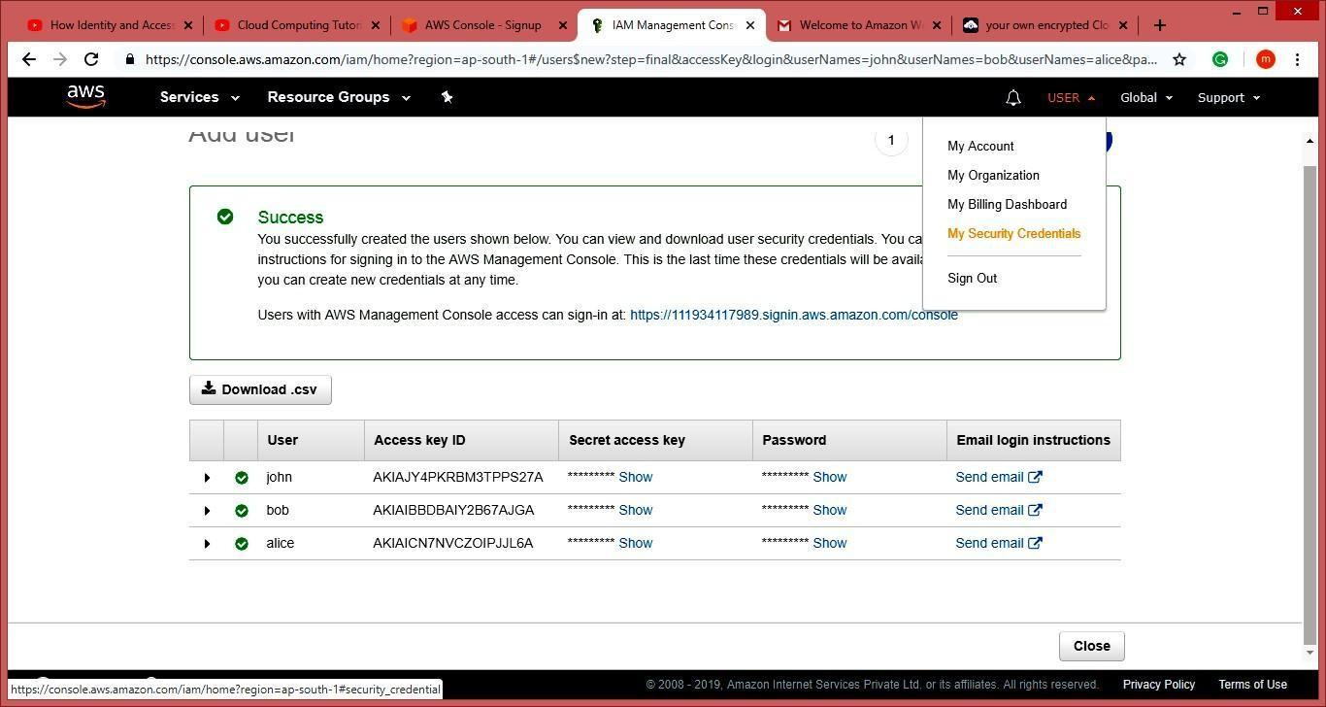

**Step14: Click on “Group”. You will see the group you just created.**



**Step15: Now** **log** **out** **of** **admin** **account** **and** **try** **to** **login** **as** **user** **(newly** **created).**

**Navigate to link below.** [**https://aws.amazon.com/console/**](https://aws.amazon.com/console/)

**Go to “My Account” > “AWS Management Console”.**



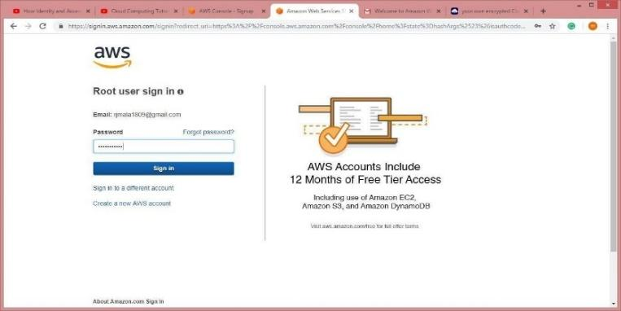

**It** **will** **ask** **you** **to** **change** **the** **password** **which** **is** **been** **set** **by** **administrator.** **You** **will** **be** **redirected** **to** **home** **screen.**



**Practical No. 6**

**Aim: Study Cloud Security Management**

**Step1:** Go to aws.amazon.com

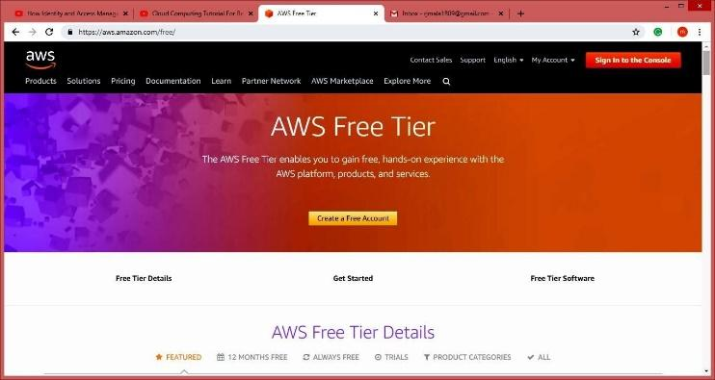

**Step2:** Click On My Account.

**Step3:** Select aws management console and click on it.

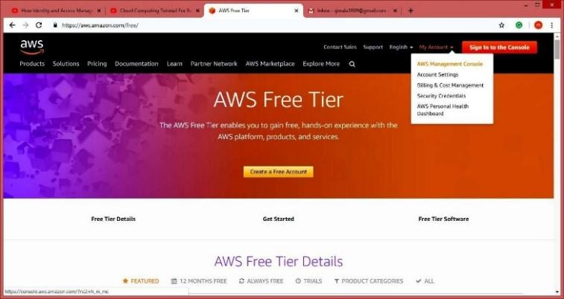

**Step4:** Create AWS account(fill the required details)

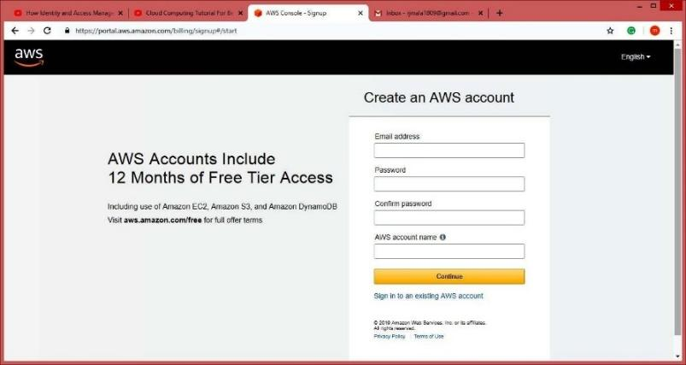







**NOTE :-** **Do** **not** **provide** **any** **kind** **of** **credit/debit** **card** **details** **or** **bank** **details.)**

**Step5:** Click on next (open your gmail check you will get message from amazon).

**Step6:** Click on My Account, Select AWS Management Console.

**Step7:** Enter your aws account userid and password click on sign in button





**Step8:** Click on Services tab



**Step9:** Click on Security, identity & Compliances > Select IAM

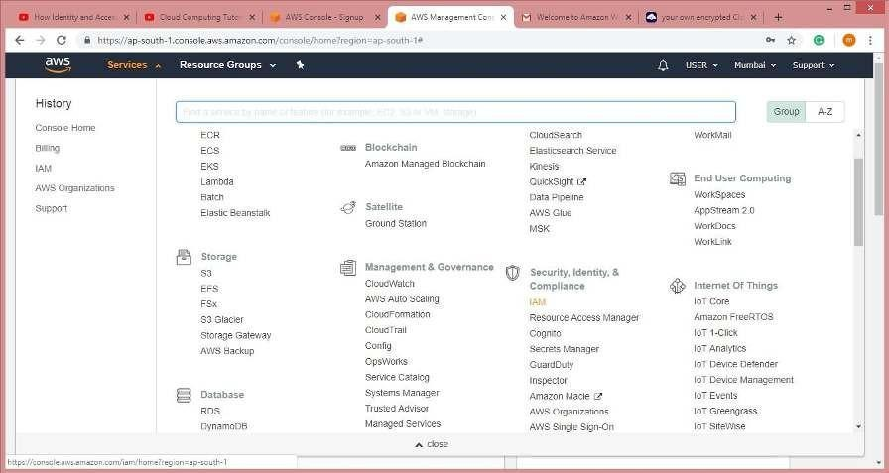

**Step 10:** Click on Users from Dashboard



**Step11:** Click on Add User and Add the users.



**Step12:** Goto Select AWS access type check both the rediobutton. And click on next permission

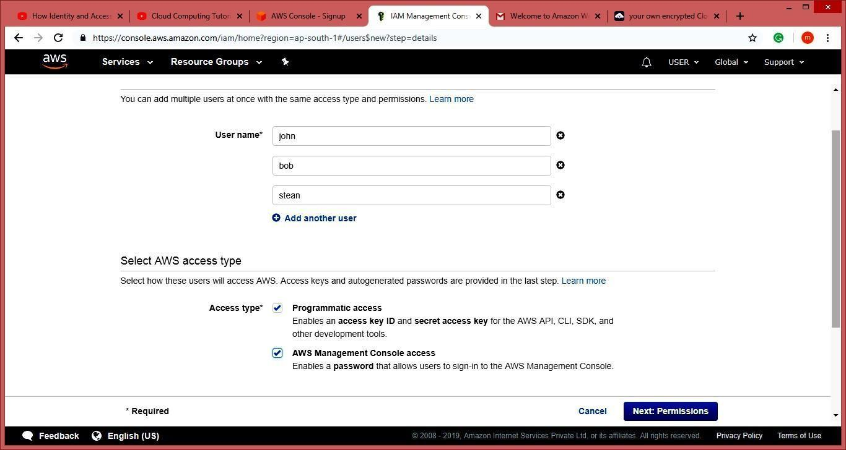

**Step13:** Click on Attach Existing Policy Directly. Attach Policy to the users. And press Next Tab.

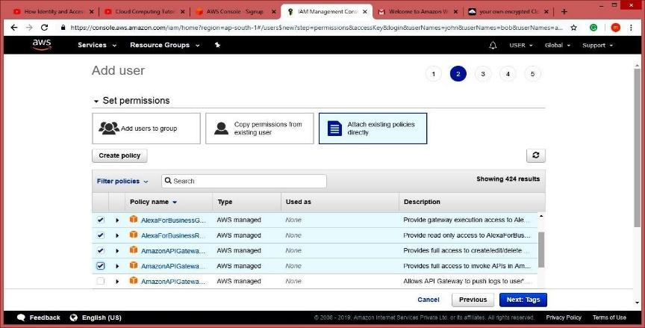

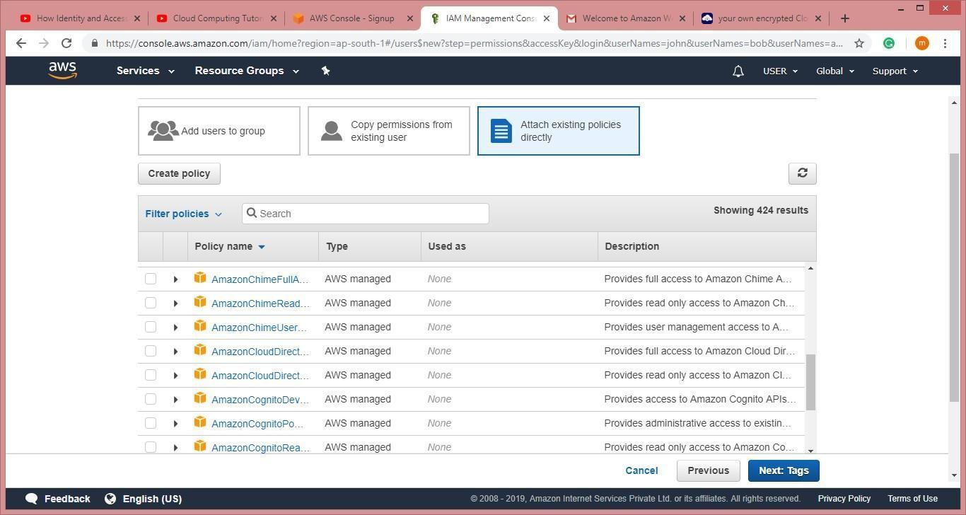

**Step14:** Click On Create User (Here Users are created.)

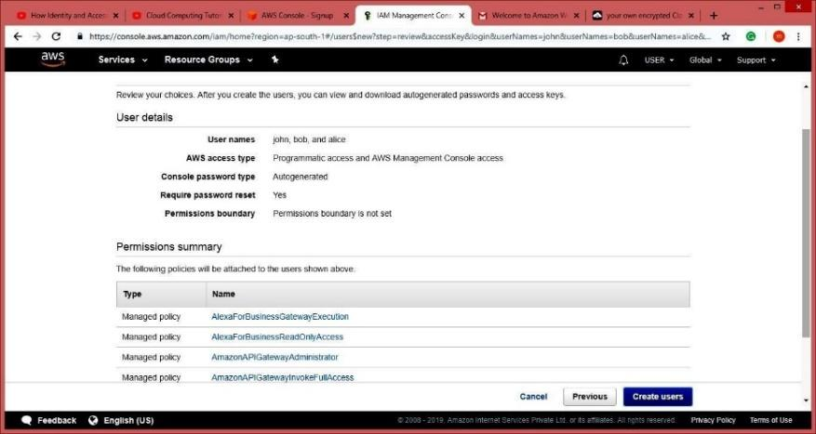

**Step15:** Now download the .csv file . and click on close.



**Step16:** Now Goto Account and select My Security Credential tab > Click on Continue to security credentials .

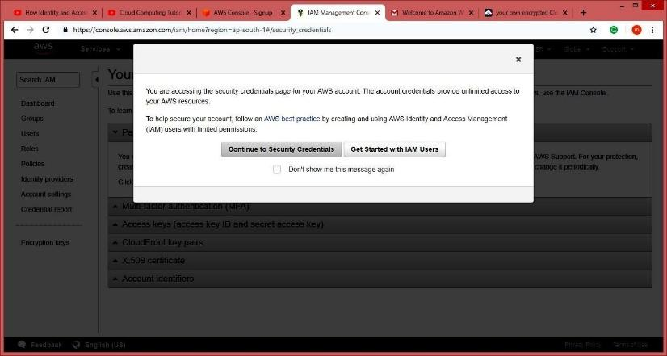

**Step17:** Click on Multi-factor authentication (MFA)

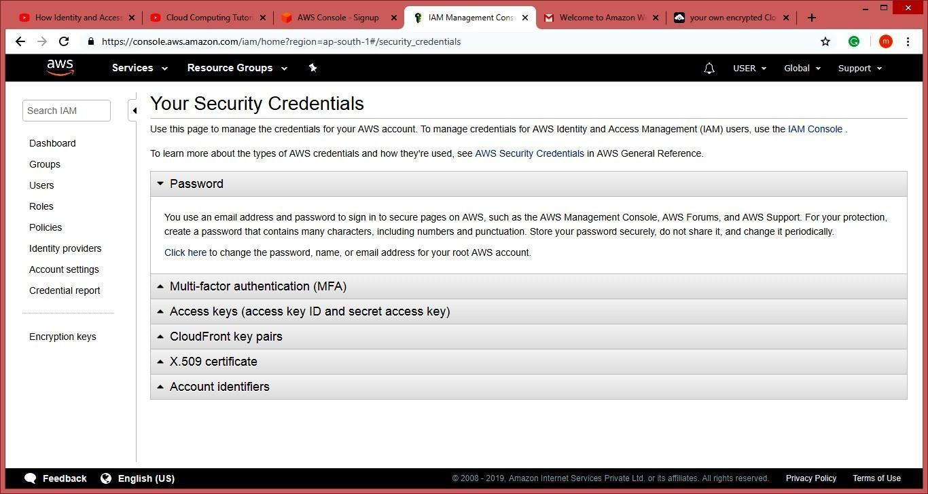

**Step18:** Click On Active MFA

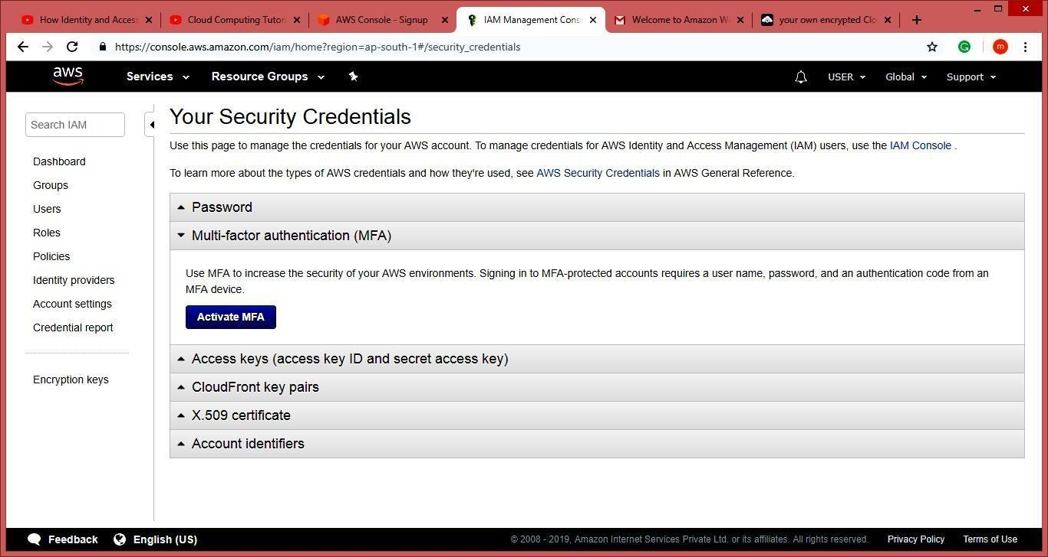

**Step19:** Select Virtual MFA device and Click on Continue tab

**Note:** **Download** **Barcode** **Scanner** **and** **Google** **Authentication** **App** **in** **your** **Mobile** **Phone.**

**Step20:** Scan the QR code and enter the MFA code from ur mobile phone and then click on assign Assign MFA tab

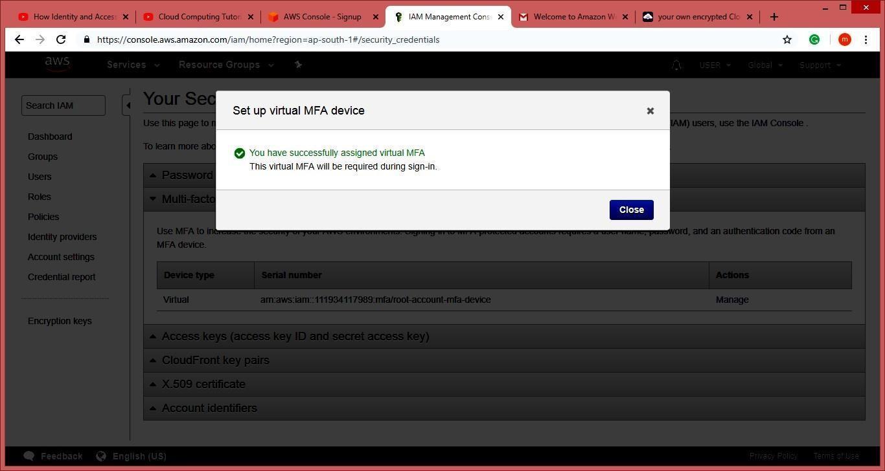

**Step21:** Now the page look like this.

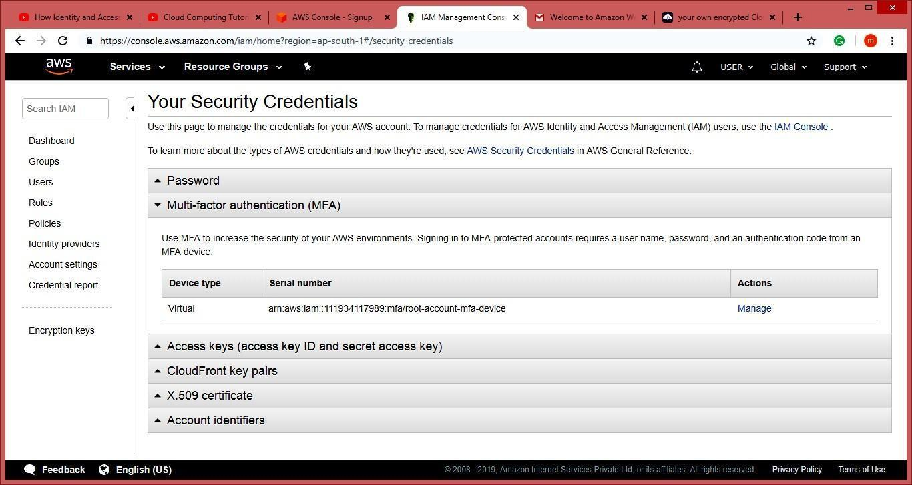

**Step22:** Click On Dashboard Go to Additional Information Select Policy Simulator

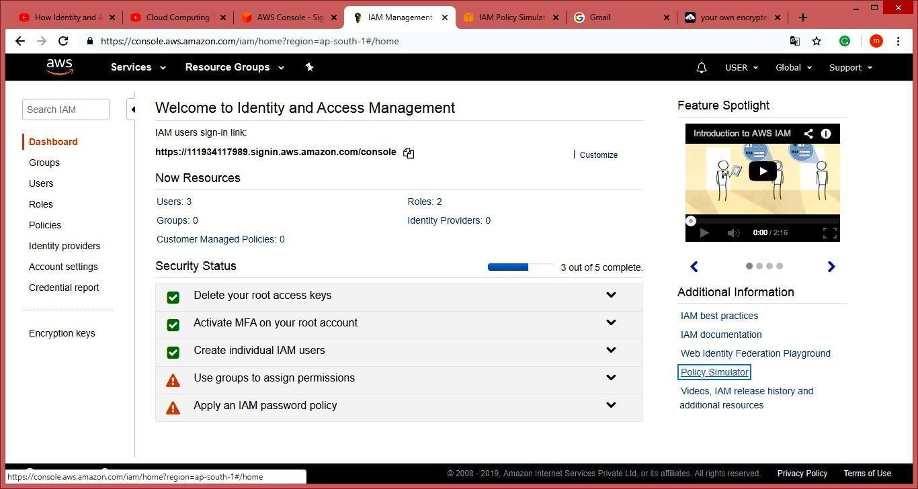

**Step23:** Select The User select services and service action and click on Run Simulator Tab

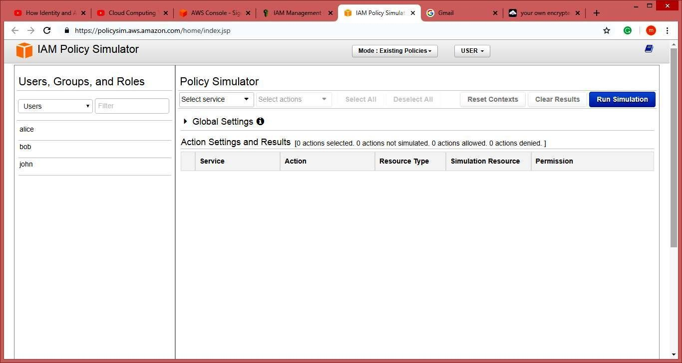

**Practical No. 7**

**Aim: Write a program for web feed**

**Steps:**

**Step1: Open** **Notepad** **File** **Type** **the** **following** **Code** **and** **save** **it** **as** **rss.xml** **extension.**

<?xml version="1.0" encoding="UTF-8"?>

<rss version="2.0">

<channel>

<title>W3Schools Home Page</title>

<link>https:/[/www.w3schools.com](http://www.w3schools.com/)</link>

<description>Free web building tutorials</description>

<item>

<title>RSS Tutorial</title>

<link>https:/[/www.w3schools.com/xml/xml_rss.asp](http://www.w3schools.com/xml/xml_rss.asp)</link>

<description>New RSS tutorial on W3Schools</description>

</item>

<item>

<title>XML Tutorial</title>

<link>https:/[/www.w3schools.com/xml<](http://www.w3schools.com/xml)/link>

<description>New XML tutorial on W3Schools</description>

</item>

</channel>

</rss>

**Step2: Open** **the** **software** **visual** **studio** **2010** **Do** **the** **following** **File** **->** **New** **->** **Website->** **visual** **C#** **->** **ASP.NET** **website** **->** **OK**

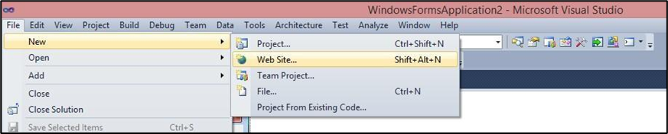

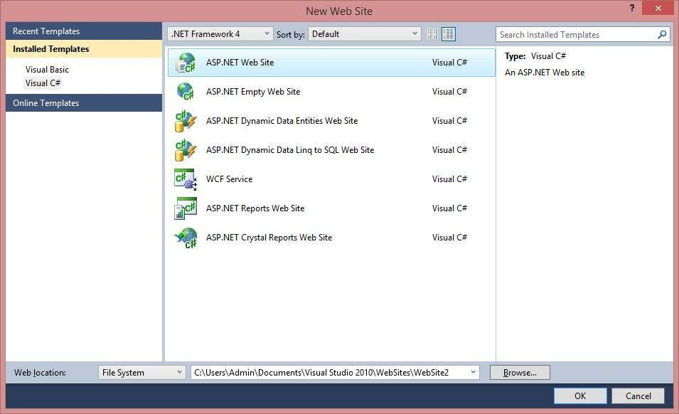

**Step3:** **Now** **copy** **that** **rss** **file** **which** **was** **saved** **with** **.xml** **extension** **inside** **your** **website** **folder.**

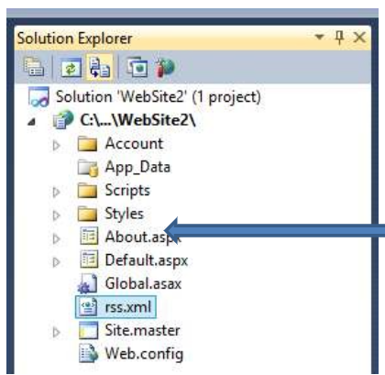

**Step4: Type** **this** **in** **default.aspx** **<p>here** **is** **ur** **<a** **href="rss.xml">feed</a>.</p>**

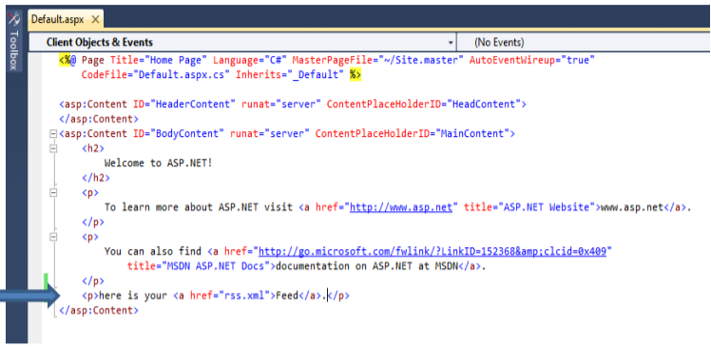

**Step5:** Run the page

**Output:**

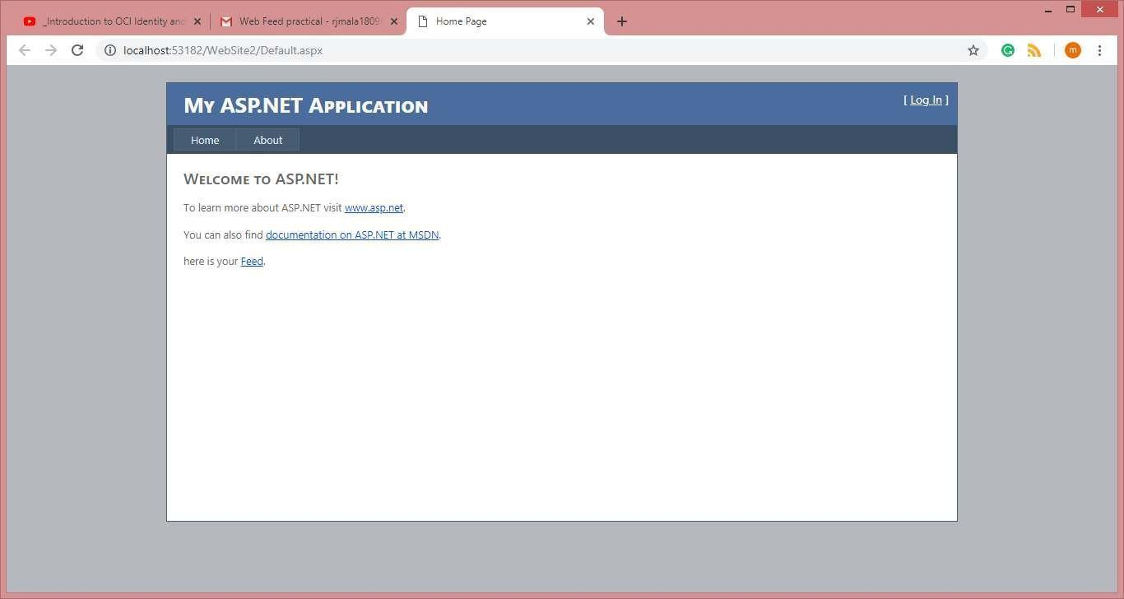

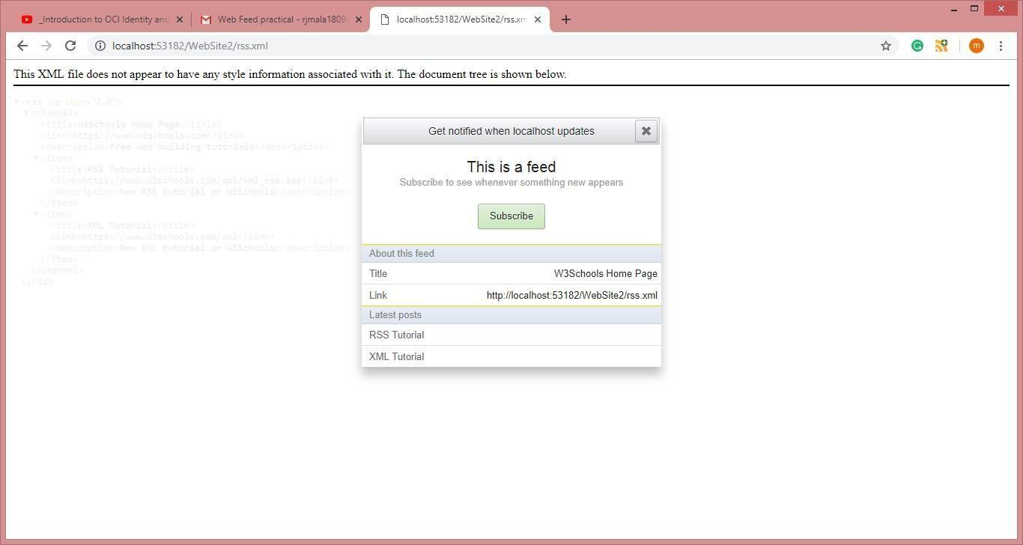

**Practical No. 8**

**Aim:** Study and implementation of Single-Sign-On.

**1. Visit the Auth0 website:**

* Open your Chrome browser and go to the URL:

<https://auth0.com/learn/how-to-implement-single-sign-on>

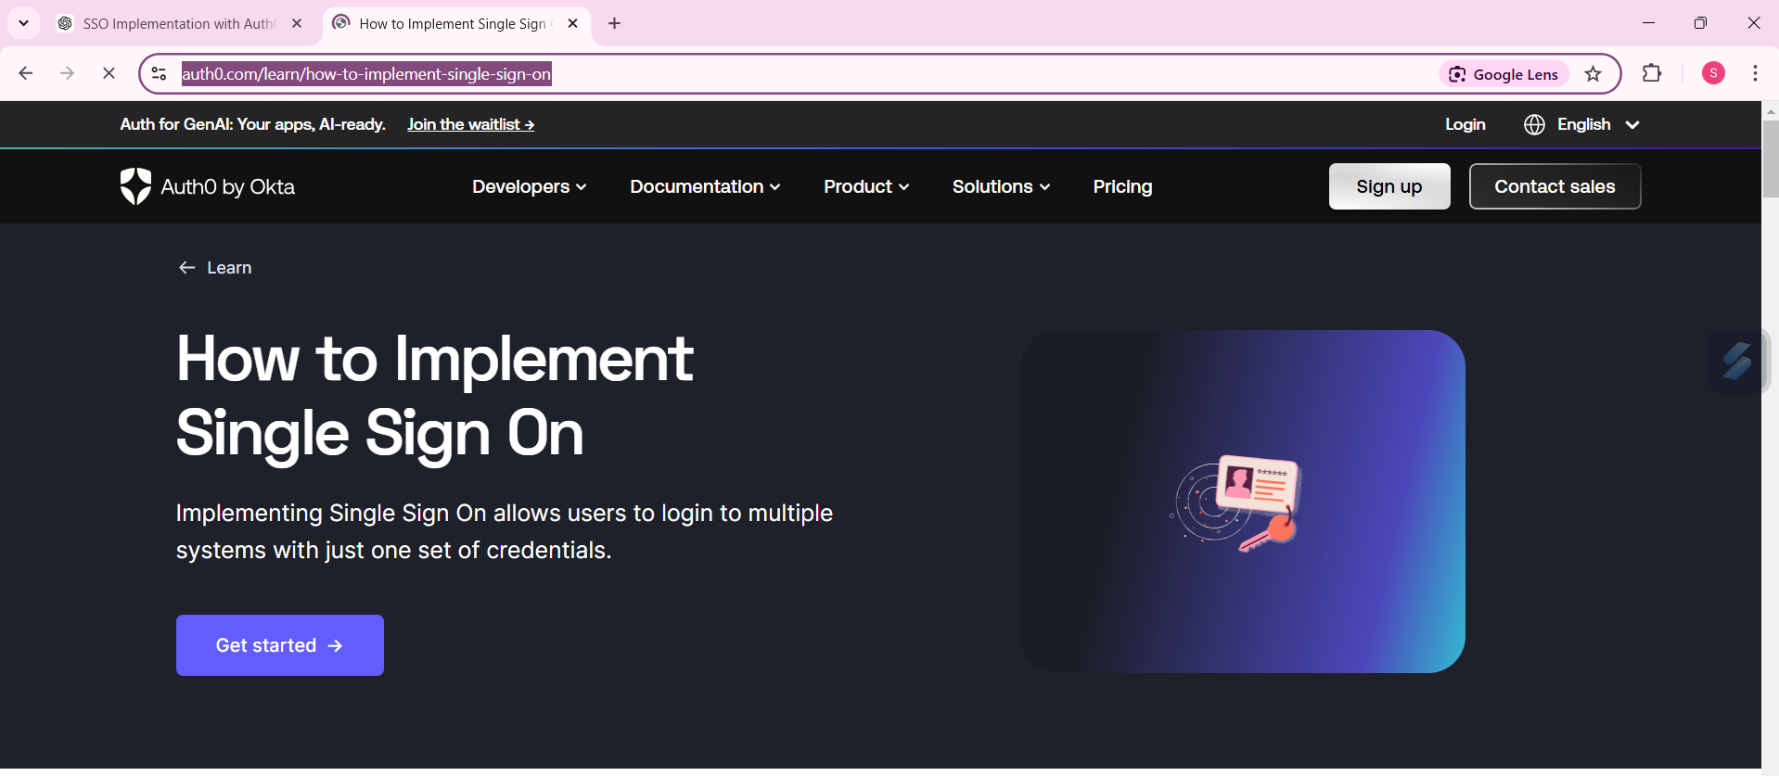

**2. Sign up for Auth0:**

* If you don’t have an account, you will be prompted to sign up.
* Provide the required details:

1. User name (e.g., email or a custom username)
2. After entering the username, click Next.

* On the next screen, select:
* Account Type: Personal
* Scroll down, and click Try for Free to proceed.

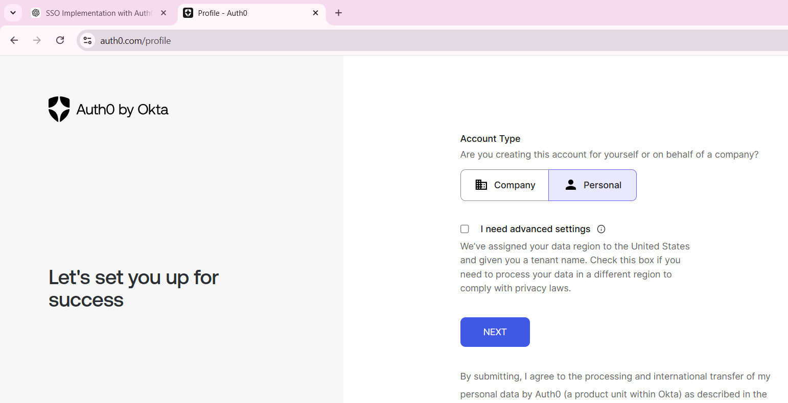

**3. Create your account:**

* Click Login
* Fill in your information (email, password, etc.), and click Next to complete the signup process.

**4. Navigate to the Dashboard:**

* After successfully signing up, you will be redirected to your Auth0 Dashboard.
* Here, you can manage applications and services.

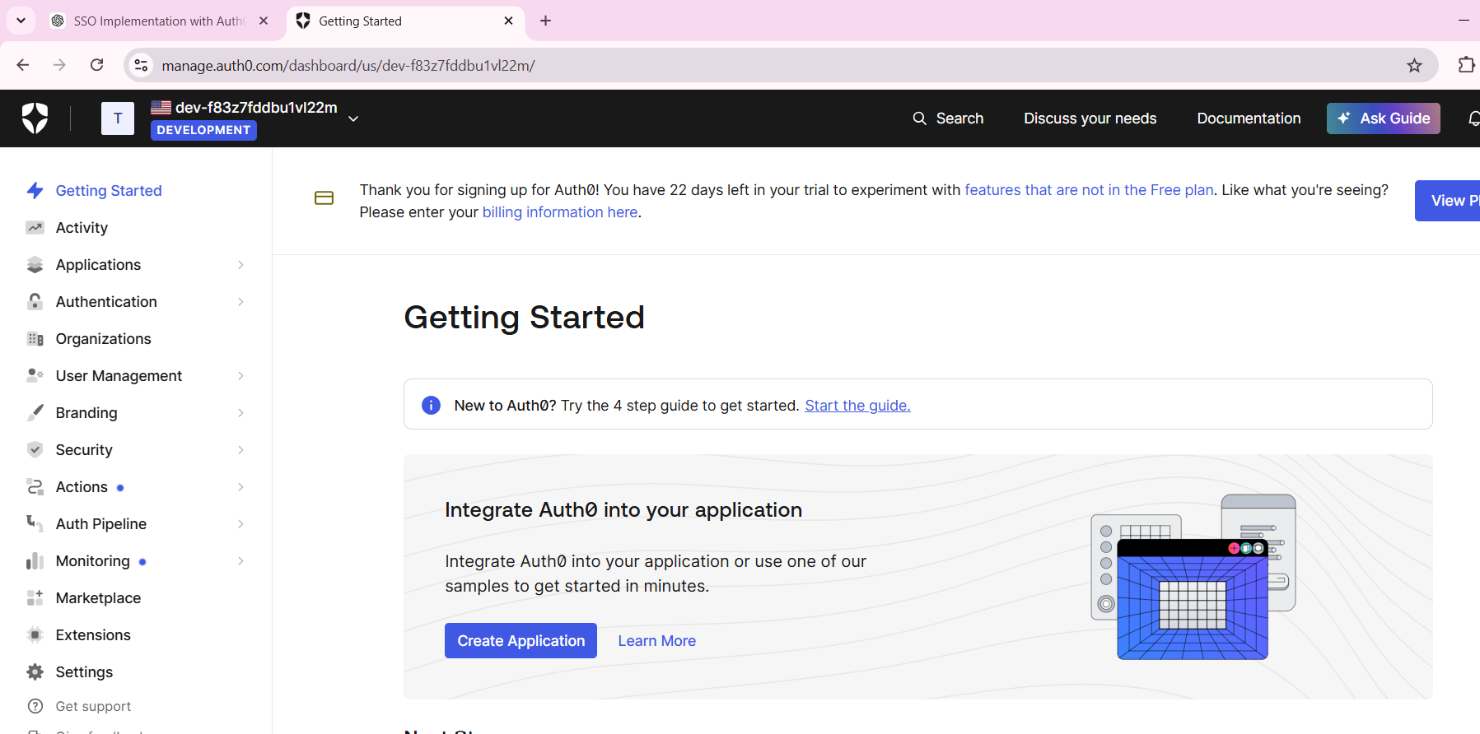

**5. Configure Authentication (SSO):**

* Click on Authentication from the left sidebar.
* Select Social under the Authentication section.
* From the list of social providers, click on Google OAuth2 (Google will be used for Social Login integration).

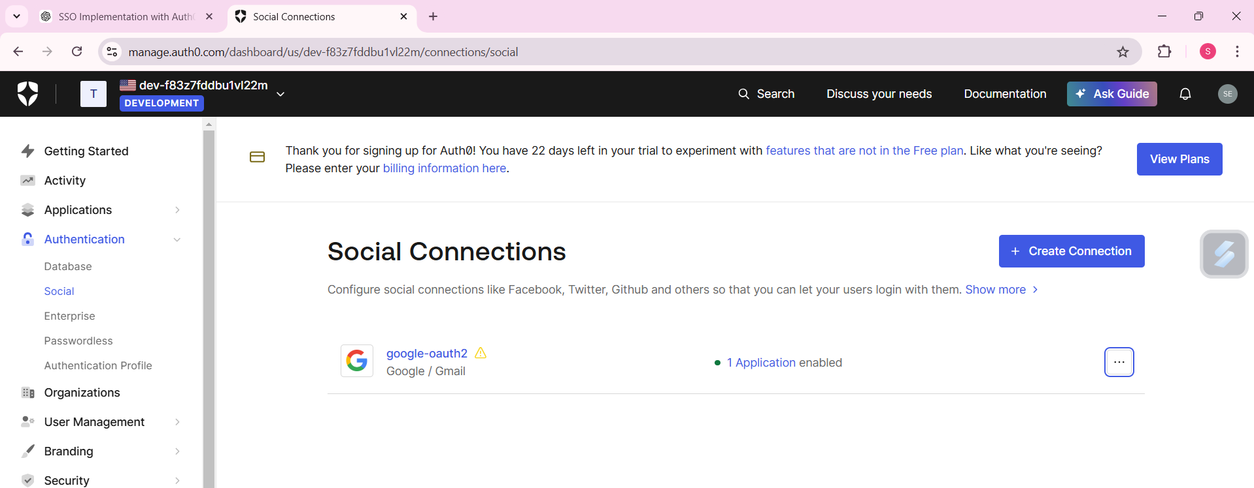

**6. Try Connection:**

* After selecting Google OAuth2, click on the Try Connection button.
* You will be prompted to sign in with your Google account to complete the setup.
* Once signed in with your Google account, you should see confirmation that the connection has been successfully established.

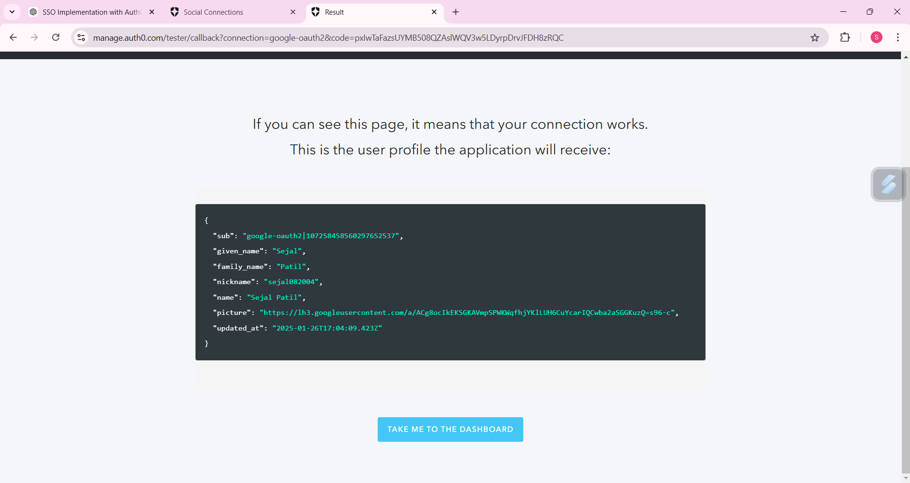

**7. Test and Use:**

**Start the Guide**:

* Once your authentication (SSO) is set up, click on **Start the Guide** to proceed with integration steps for your application.

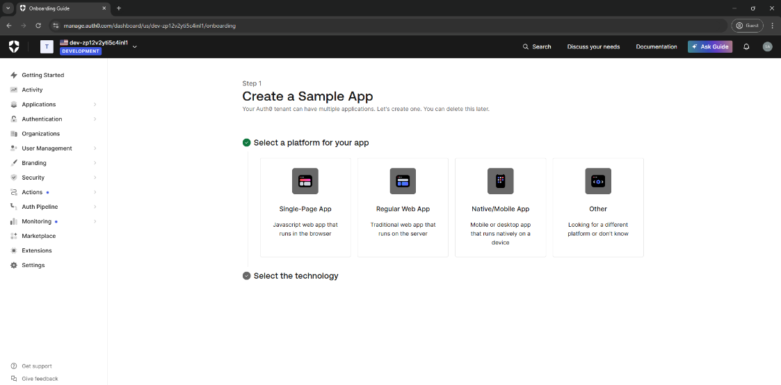

**Select Application Type**:

* Choose **Others** to customize the integration according to your needs.

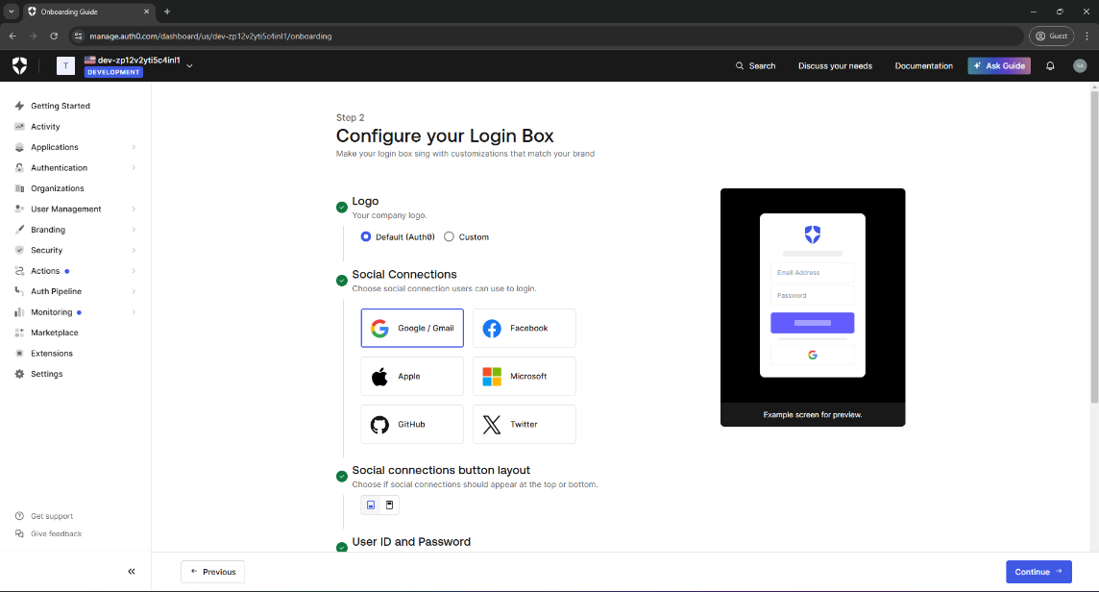

**Design Your Application**:

* Tailor the application setup based on your requirements and click **Continue** to proceed with configuration.

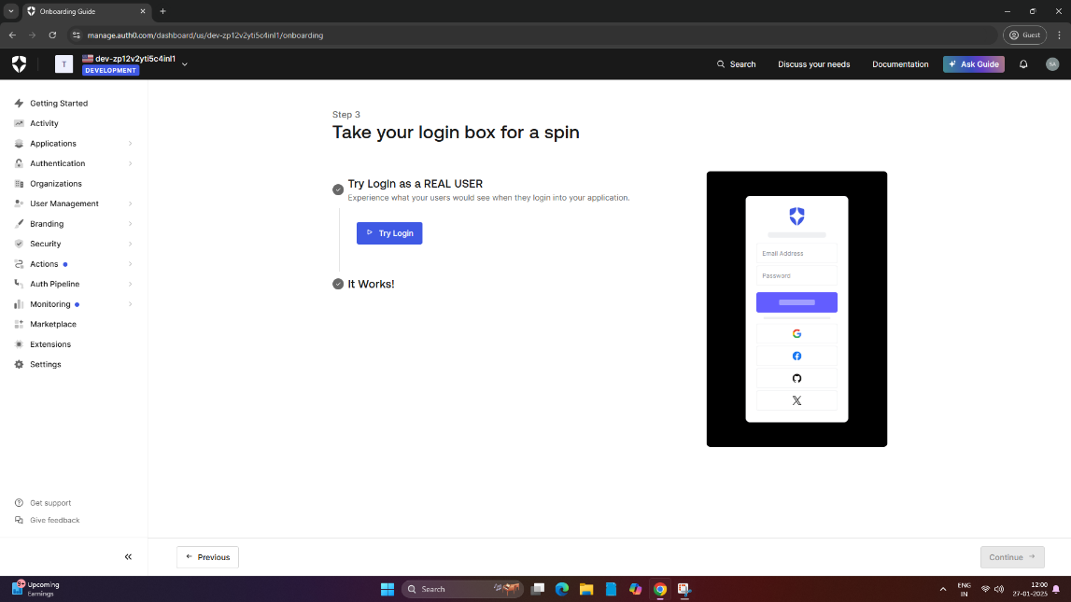

**Test Login**:

* Click on **Try Login** to test the SSO process.
* If prompted, choose **Continue with Google** to authenticate using your Google account.
* If successful, you will be redirected to your Google account page.

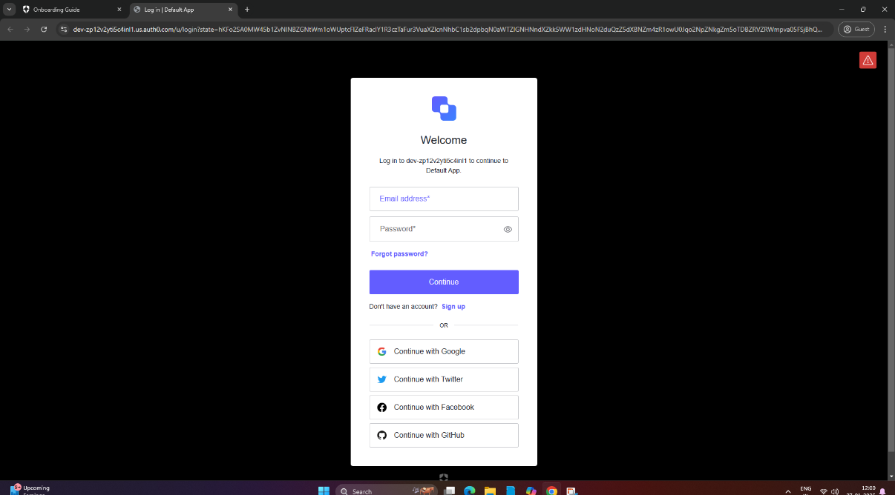

1. **Download Sample App**:
   * Download the **Sample App** to see the working example of the SSO implementation.
   * After reviewing the app, click **I am ready to use Auth0** to complete the setup.

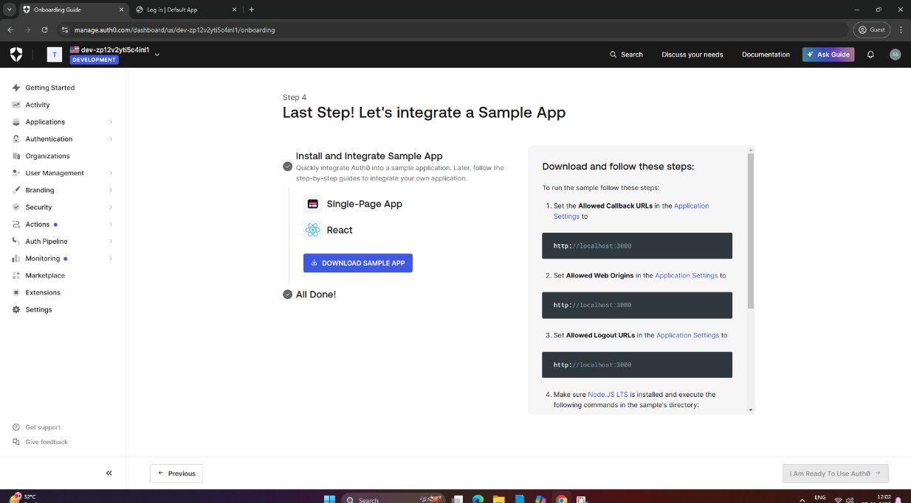

### Conclusion:

By following the above steps, you can successfully integrate **Single Sign-On (SSO)** into your application using Auth0. This allows users to authenticate with their Google account and access multiple services without repeated logins, improving both user experience and security.

**Practical No. 9**

**Aim:** User Management in Cloud

**Steps:**

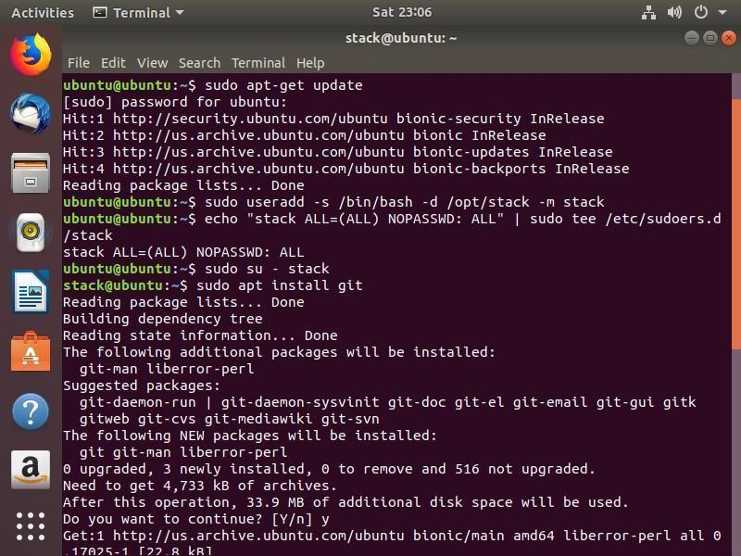

**Step1:** Adding a user on Ubuntu: **sudo adduser rjcs**

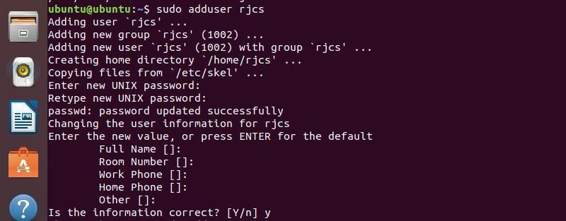

**Step2: To** **add** **a** **system** **user** **rjcs** **run** **the** f**ollowing** **command:**



**Step3: Login as rjcs user by using following command:**





**Step4: Adding** **a** **group** **on** **Ubuntu**

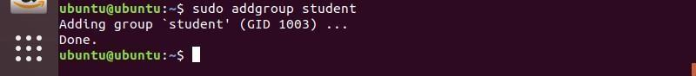

**Step5: Adding** **a** **User** **to** **a** **group** **on** **Ubuntu:**



**You can login as a rjcs and run the following command.**





**Step6:** **Removing** **the** **user** **from** **a** **group** **on** **Ubuntu:**

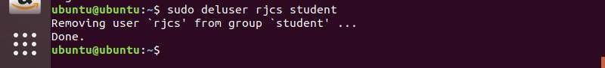

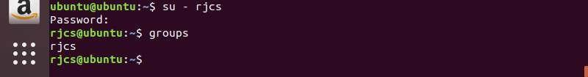

**Step7: Removing a user on Ubuntu:**

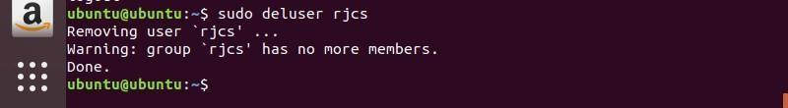

**Step8:** **Deleting** **a** **group** **on** **Ubuntu:**

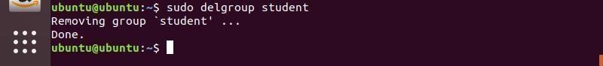

**Step9:** **Listing** **all** **the** **users** **on** **Ubuntu:**

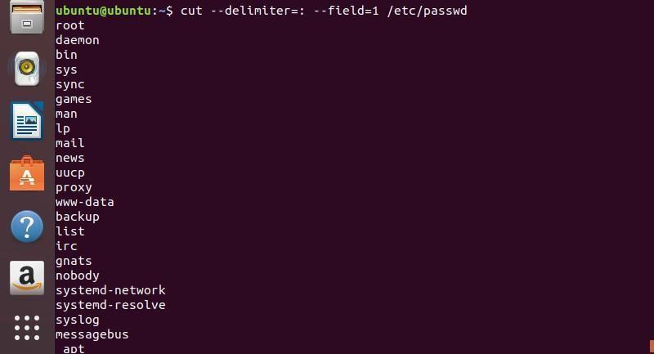

**Step10:** **Listing** **all** **the** **groups** **on** **Ubuntu:**

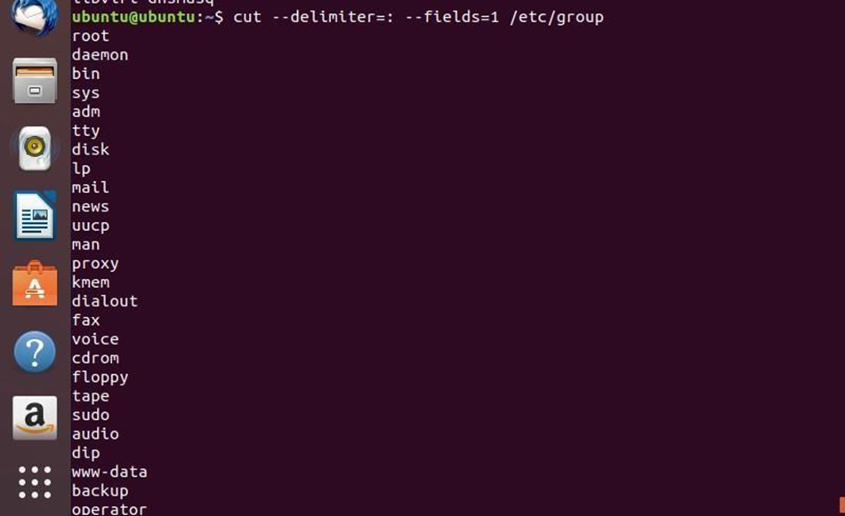

**Step11: Listing** **all** **the** **user** **in** **a** **group** **on** **Ubuntu**



**Practical No. 10**

**Aim:** Study and implementation of Role Based Access Control in AWS Cloud

**Steps:**

**Step1: Open your browser and visit the AWS Free Tier Sign-Up page 👉** [**https://aws.amazon.com/free**](https://aws.amazon.com/free) **> Click on "Create an AWS Account".**

**Step2: Enter Your Details:**

1. Account Information
2. AWS Account Name [MyCloudLearning]
3. Choose Account Type
4. Payment Information
5. Verify Your Identity
6. Choose a Support Plan [Free Basic Plan]

**Step3: Sign in to AWS Management Console, Once logged in, ensure that you are in the correct AWS region (top-right corner).**

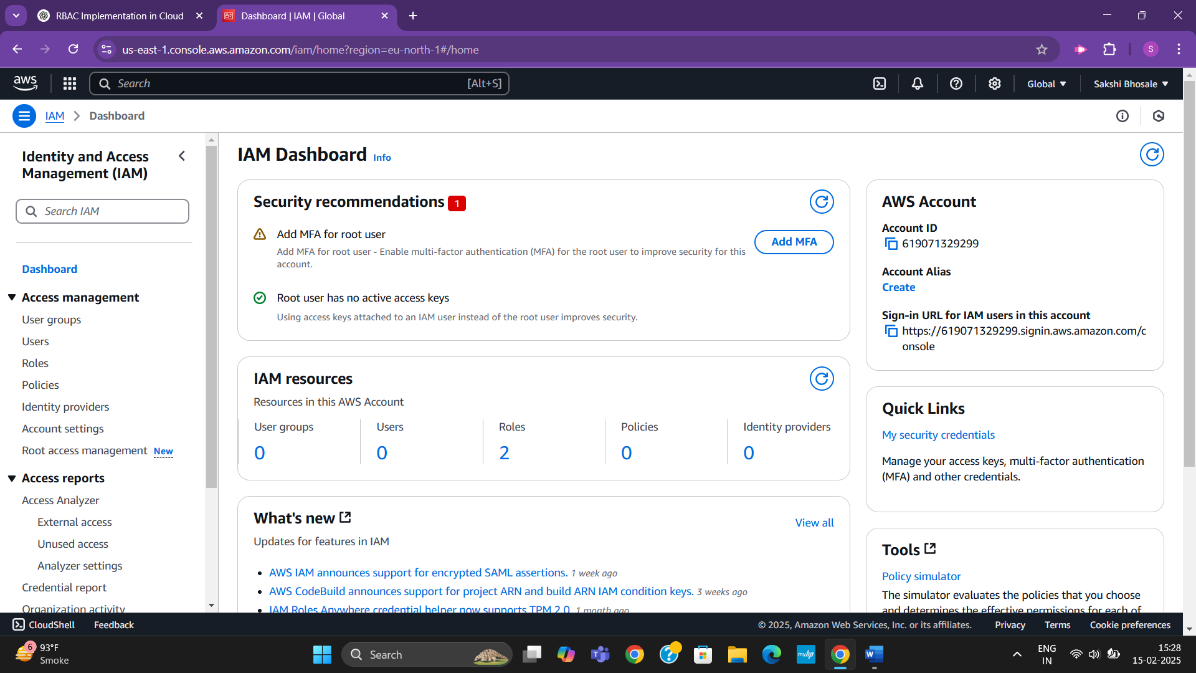

**Step4: Type "IAM" and click on IAM under Services > Roles > Create Role**

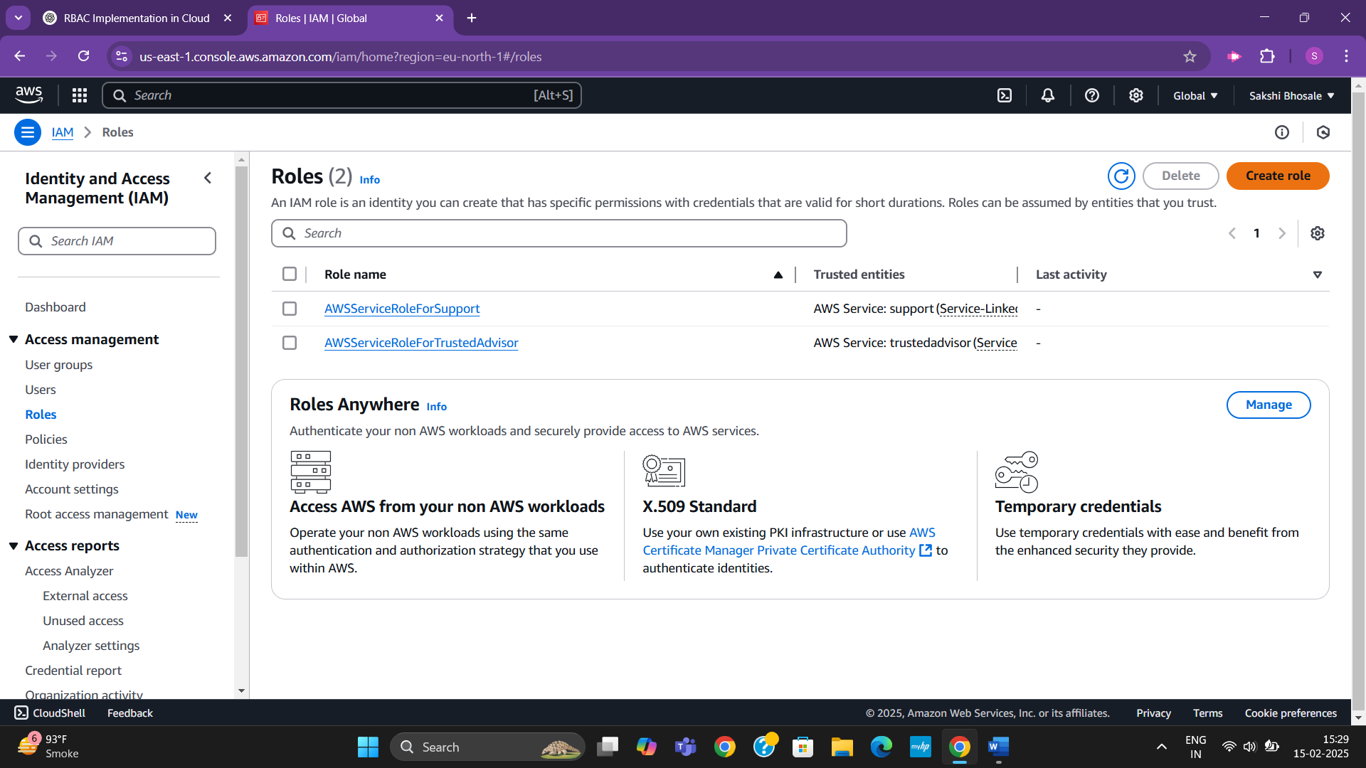

**Step5: Select AWS Service & choose EC2 as the trusted entity > Next [select role type]**

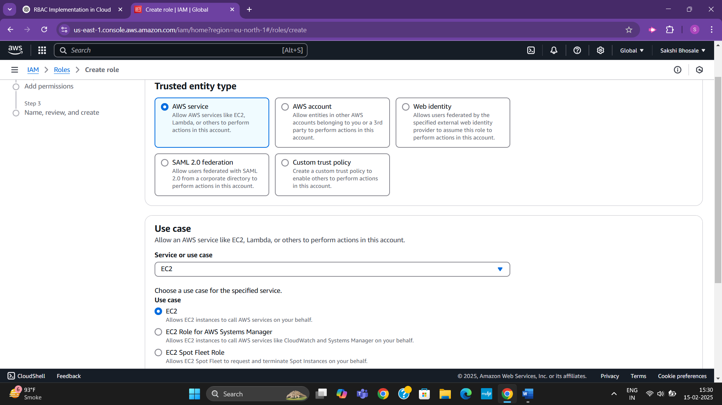**\**

**Step6: Select the AmazonS3ReadOnlyAccess checkbox > Next**

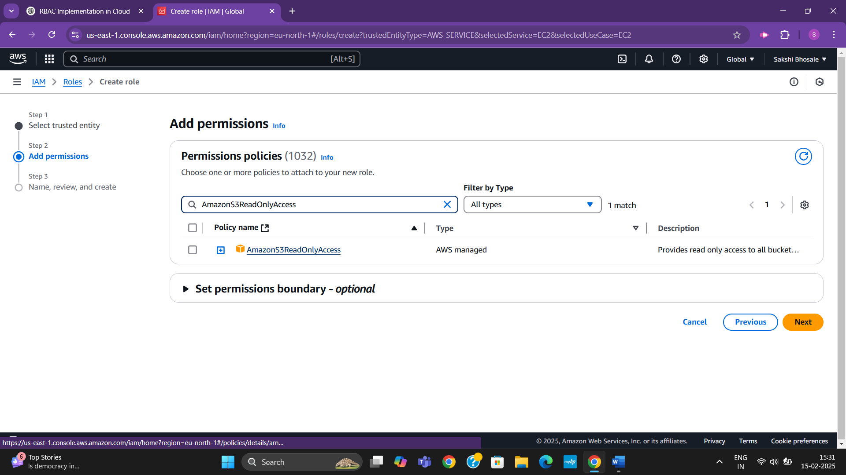

**Step7: Enter a meaningful role name, [S3_ReadOnly_Role] > Create Role at bottom of page**

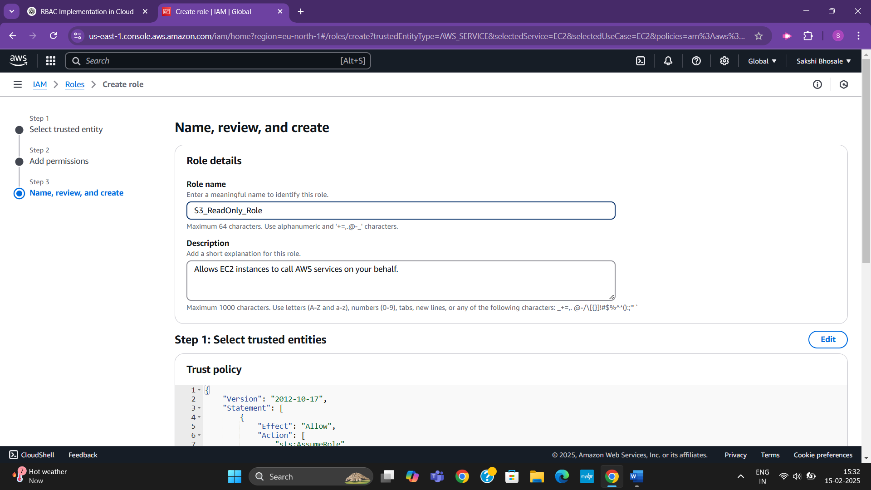

**You have successfully created an IAM role. Now, you can attach this role to an EC2 instance or other AWS services.**

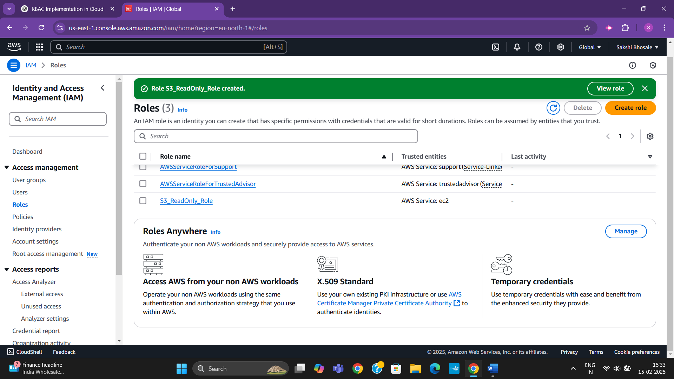

**Step8: In EC2 Dashboard, click on Instances (left side panel) > (blue)Launch Instances. [Launch EC2 Instance]**

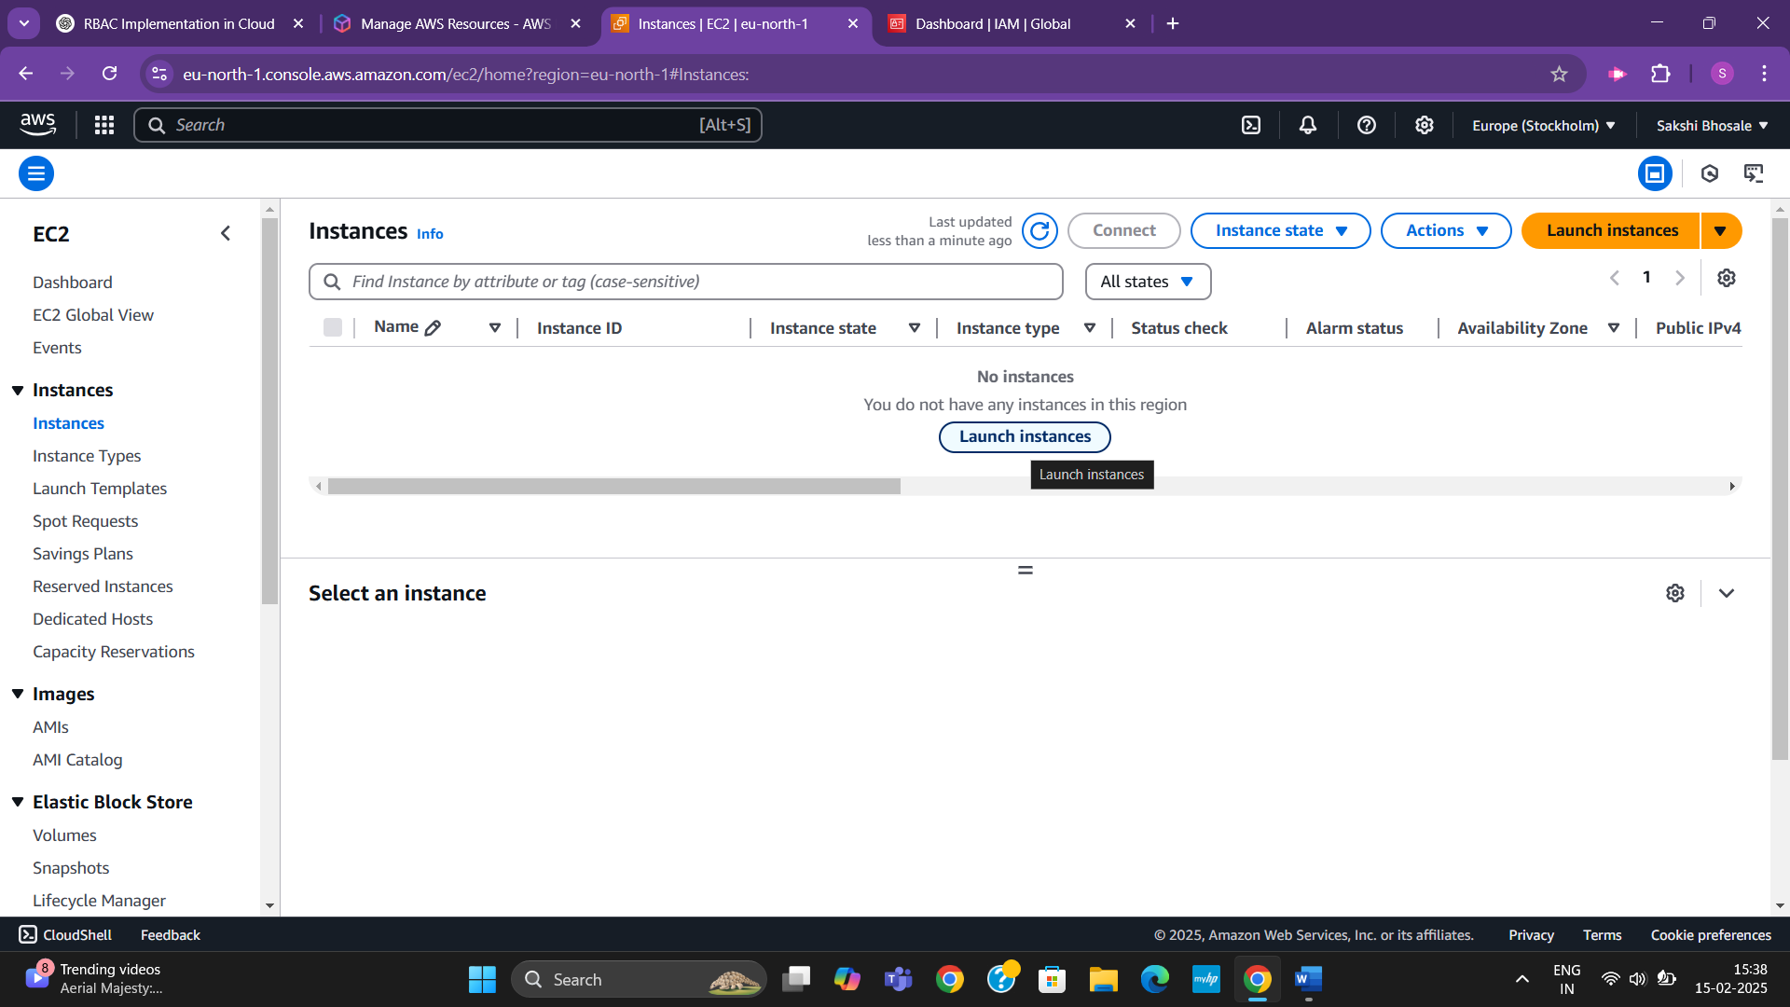

**Step9: Configuring EC2 Instance by selecting below things:**

1. Name Your Instance under Name and Tags [MyTestEC2]
2. Scroll down to Application and OS Images (Amazon Machine Image - AMI) > Choose Amazon Linux 2023 (Free Tier eligible) (will install amazon linux)
3. Under Instance Type, select t2.micro OR t3.micro (Free Tier eligible)
4. Under Key pair (login), click Create new key pair [MyEC2Key] > RSA as (key type) > Create Key Pair and download the .pem file.
5. Under Network Settings, leave the defaults & make sure Allow SSH traffic is enabled so you can connect to the instance.
6. Under Configure Storage, keep the default 8 GiB (General Purpose SSD - gp3).

**Step10:** Now, you will attach the IAM role you created (S3_ReadOnly_Role) to the EC2 instance by scroll down to Advanced Details > IAM Instance Profile (dropdown) > select S3_ReadOnly_Role > Launch Instance

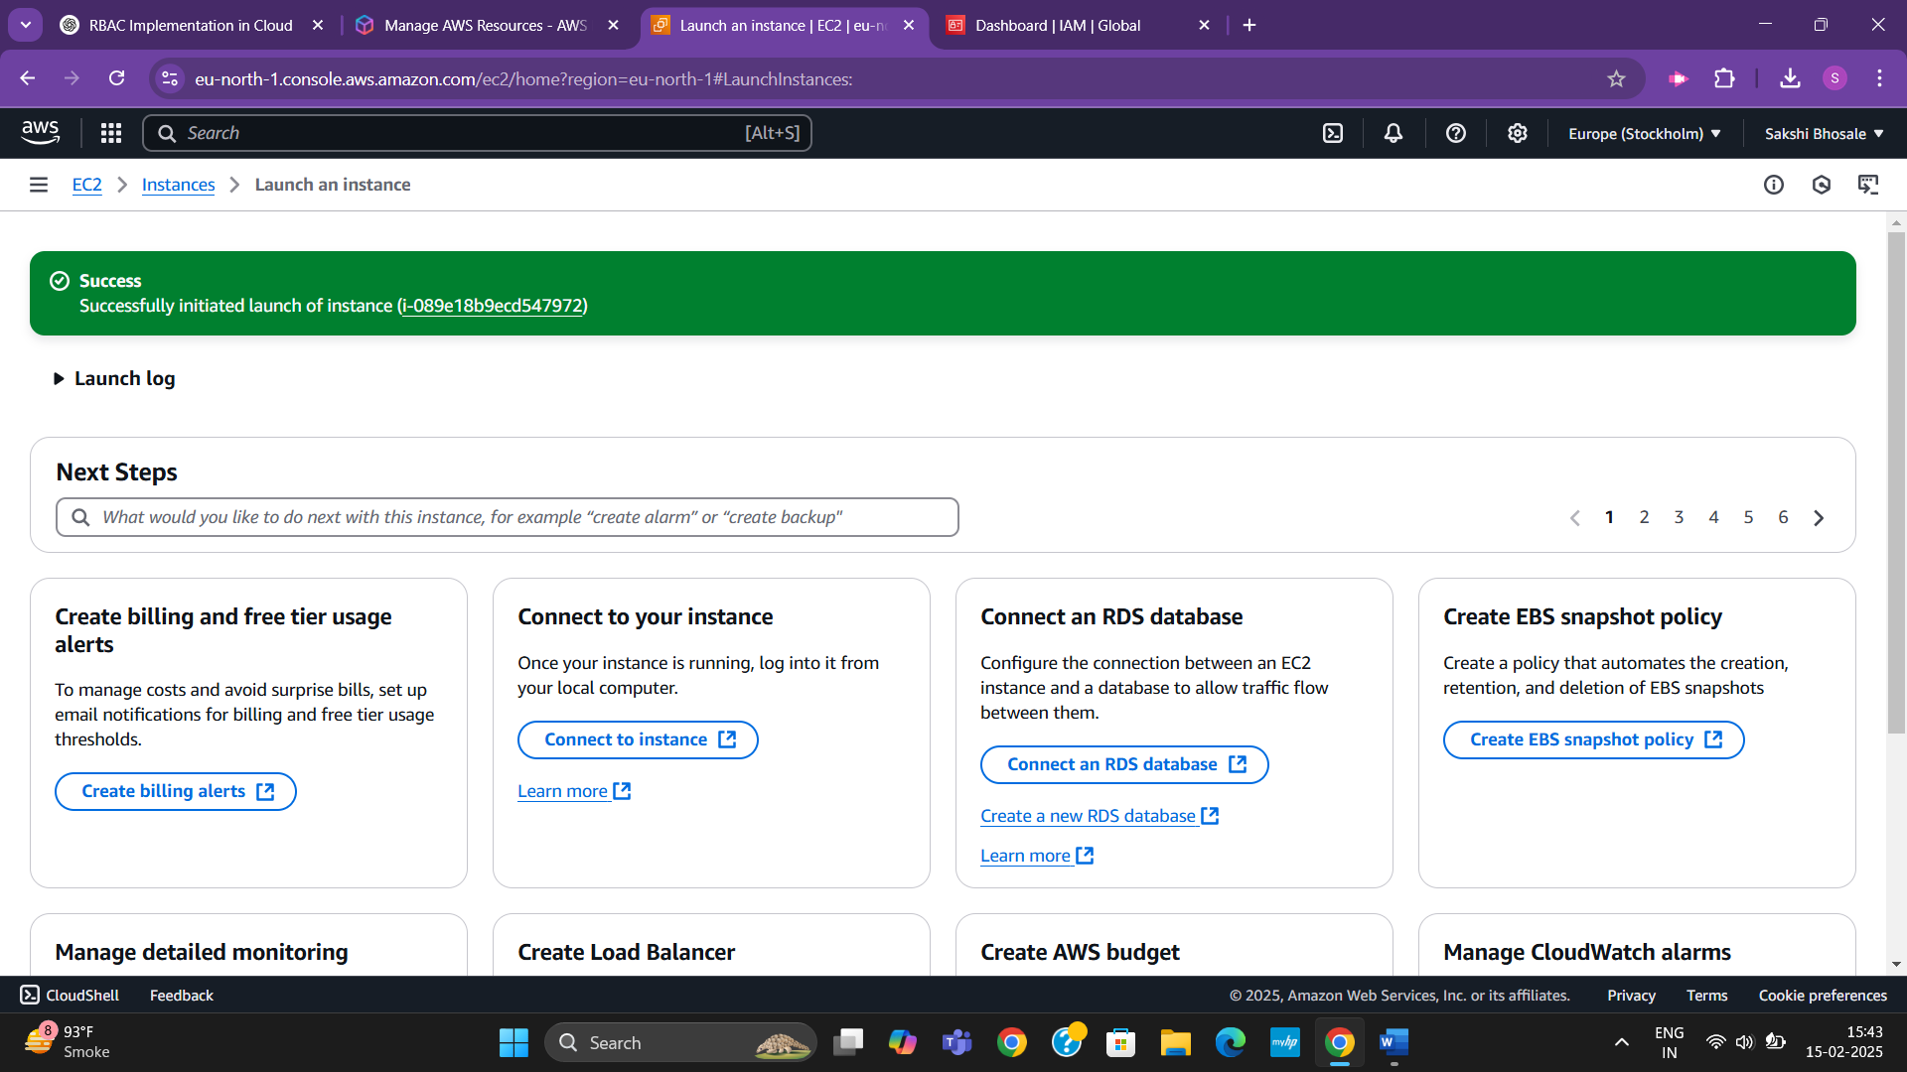

**Once the instance is launched, verify that the IAM role is attached**

**Step11:** EC2 Dashboard → Click Instances (left panel) > find launched instance > click on it & open its details > In Details tab, look ‘IAM Role field’ it should show S3_ReadOnly_Role

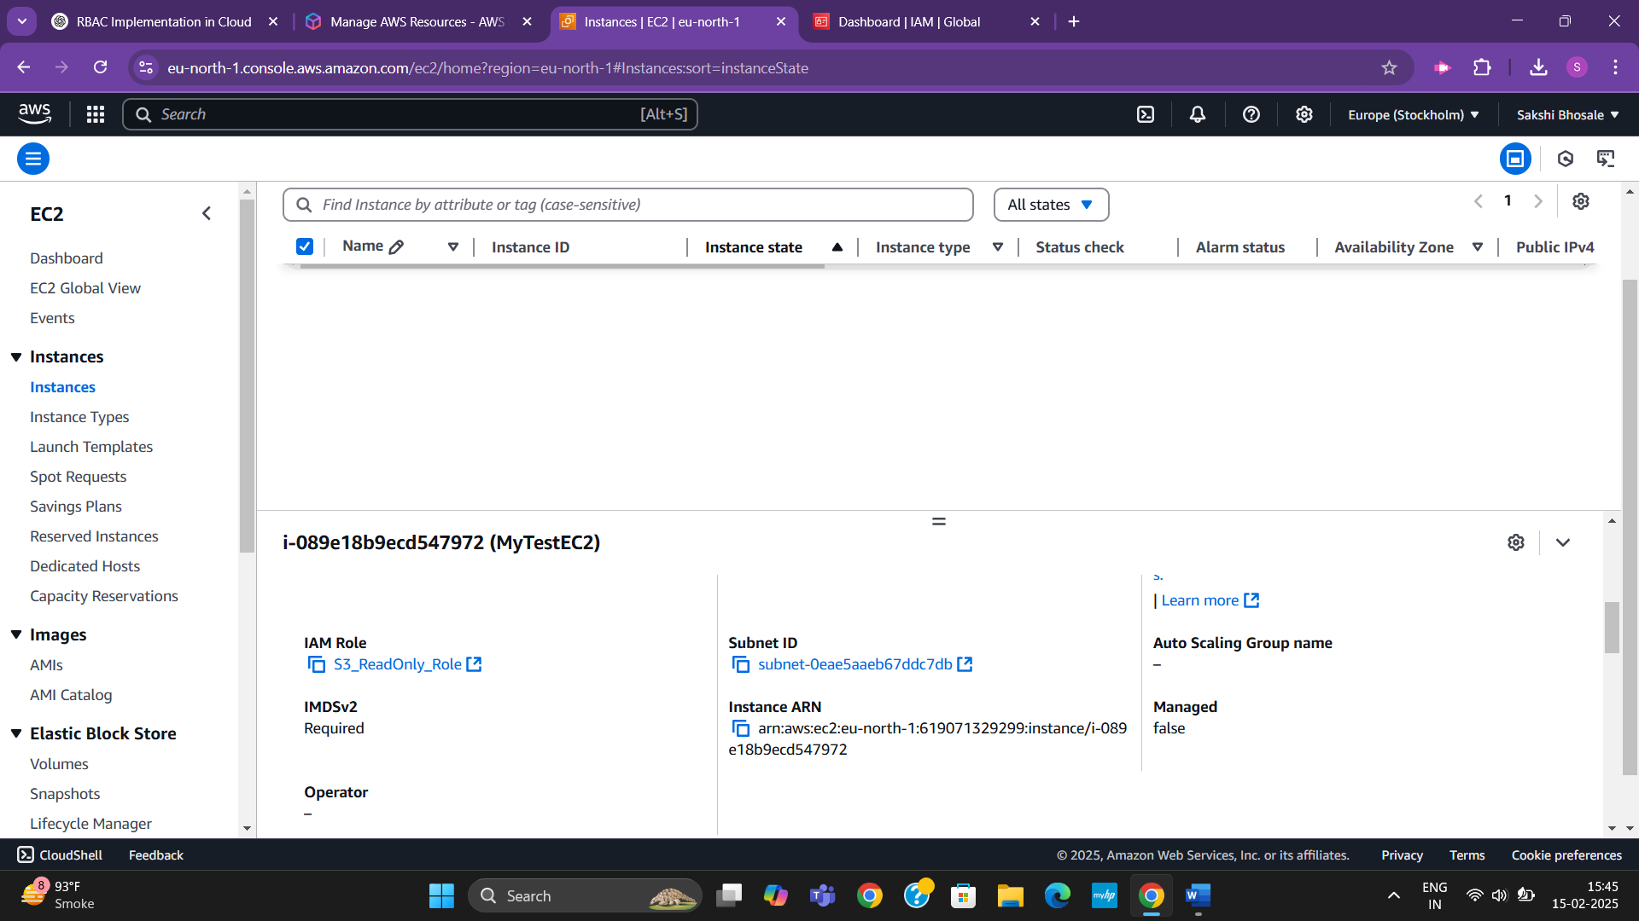

**If the IAM role is displayed correctly, your EC2 instance has IAM permissions attached successfully.**

**Step12: Now, let’s connect the role to the instance and accessing S3:**

1. Under Instance Details, find the Public IPv4 address and copy it
2. Open Command Prompt, run the command “ssh -i your-key.pem ec2-user@your-ec2-public-ip”

Replace ‘your-key.pem’ → Path to your downloaded key file

‘your-ec2-public-ip’ → The public IPv4 address of your EC2 instance > Yes

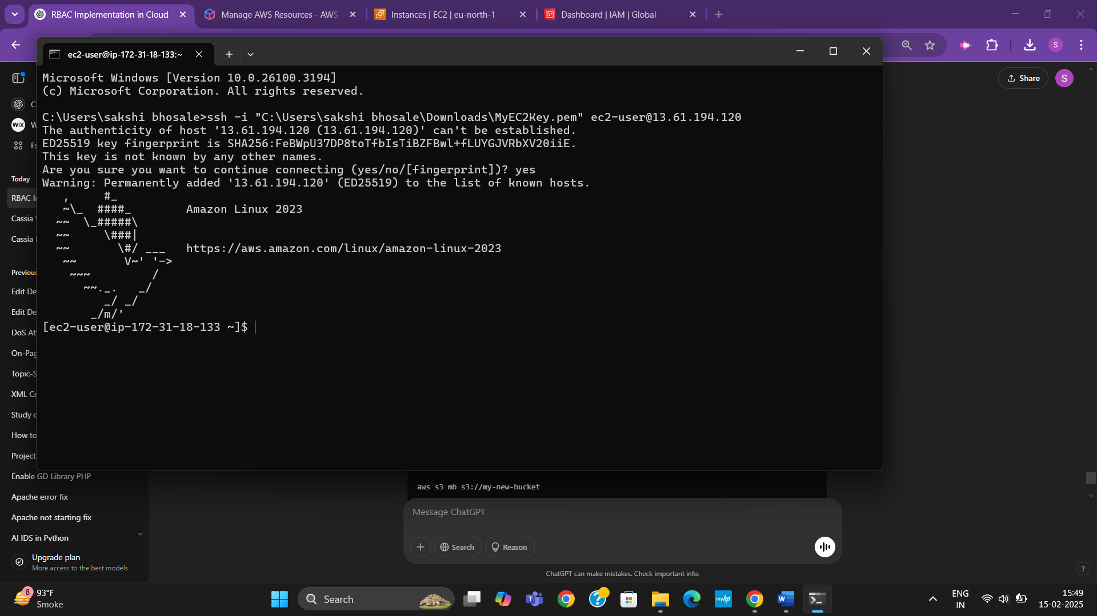

**Step13: Test S3 Read-Only Access as we are connected to instance, follow below steps:**

1. Run this command to list all S3 buckets in your AWS account [aws s3 ls] - It will successfully read the command

**Step14:** Test S3 Modify Access by creating a new S3 bucket type this command [aws s3 mb s3://my-new-bucket]

You should get a permission denied error, confirming that the role only allows read access

